TSTool Developer Manual

This manual describes the various build and test mechanisms and how to use them in the developer sandbox using Eclipse and Ant.

Compiling Source and Test Code
All production source code is in the “src” directory in its respective packages. Any new source files should be added to the “src” directory and any new test source code should be added to the “test/unit/src” directory. All files added in this fashion will be compiled without any extra development or configuration.

There are two ways that the TSTool product can be compiled in the sandbox, through Eclipse and through the Ant build file. The Ant build file will create a build directory in the main directory of TSTool with a work and test directory inside it. The work directory contains the compiled production class files and the test directory contains compile test files after a successful build. Eclipse auto-compiles the source by default and puts the class files into a “bin” directory under the main TSTool directory. Here’s an example of the TSTool build structure:

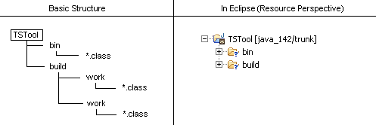

BuildStruct.bmp
Ant
- Eclipse: Right click the build.xml file and choose the second “Run as” menu item. A dialog should pop-up and from there choose the “compile” target and click “Ok.”
- Command line: Run the “compile test” target in the Ant build script under the conf directory. This target depends on the source being compiled and then it compiles the test code. The compiled source ends up in the build/work directory and the compiled test ends up in the build/test directory.

Eclipse:
The user doesn’t have to configure or run anything. Eclipse auto-compiles all production and test source code and copies it to the bin directory.

- Unit Testing
Unit test source code is kept in the “test/unit/src” directory. Any new source added to this directory will be included in the compilation and test process.

There are two ways to run unit tests for TSTool, through the Ant build file and through Eclipse. Eclipse provides a graphical output and the Ant build file outputs the results in XML.

Ant
- Eclipse: Right click the build.xml file and choose the second “Run as” option from the menu. In the pop-up dialog select the “test” target and click “Ok.” The results will be written to an XML file under test/unit/results. The statuses of the tests are also printed out to the console.
- Command line: Run the “test” target in the Ant build script under the conf directory. The tests statuses are printed to the console and results are written to the same XML file as in step 1 above.

Eclipse
Right click the tstoolTestSuite.java file in test/unit/src and choose “Run as → Junit Test” from the menu. The results will be displayed in Eclipse using the Swing Junit Runner framework similar to the image below.

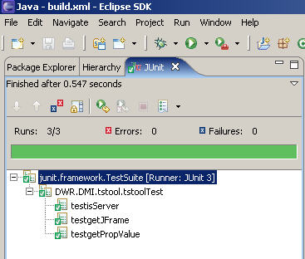

JunitResultsSwing.bmp

For more information on creating and running Unit tests see the document http://flatiron/doc/DevelopmentProcess/DevelopmentProcessTesting.doc.

3.0 Regression Testing
Since TSTool is a command-driven product; therefore, automated regression testing is fairly simple. TSTool uses command files sent in as parameters to the application on the command line to perform operations. After the operations are performed the log file is checked for errors and/or unexpected output and results are printed to an html file. Parsing and results are performed by a Perl script (parseOutput.pl) located in the test/regression/src directory. All command files are stored in the test/regression/src/commands directory. In this directory there are subdirectories with names pertaining to the types of commands files they store.

To create a new test, create a new commands file in the directory it pertains to under test/regression/src/commands that accomplishes the test needed. There are several commands already in the source directory that can be combined to create a series of operations to test. When the command files is written and ready to be tested add it to the Regression.TSTool file in the test/regression/src directory. All commands files referenced in this file will be run by the regression test.

The regression test can only be run from the Ant build file since a Perl script needs to run in order to obtain test results.

Ant
- Eclipse: Right click the build.xml file and choose the second “Run as” option from the menu. In the pop-up dialog select the “regTest” target and click “Ok.” The results will be written to an HTML file under test/regression/results.
- Command line: Run the “regTest” target in the Ant build script under the conf directory. The results are written to the same HTML file mentioned in step 1 above.
Below is an example of the HTML results file:

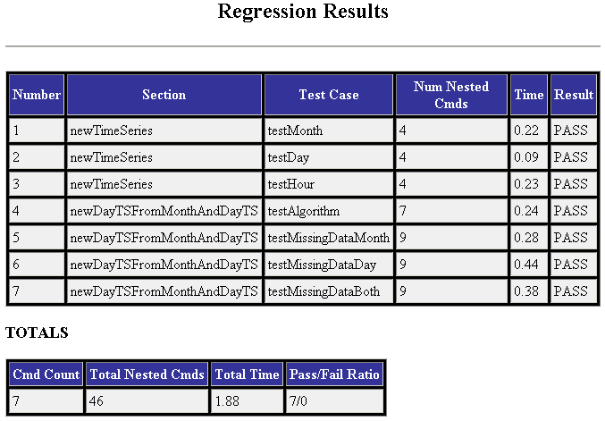

regTestResultsTSTool.bmp
- GUI Testing with Abbot
GUI testing may involve both functional and regression test types. To create and run Abbot GUI tests see the document http://flatiron/doc/DevelopmentProcess/UsingAbbot.doc.

- Running the Application
The TSTool application can be run in two different modes: CDSS and Rivertrack. The only difference is the configuration files used. TSTool can also be run from the compiled class files in the build directory and from a binary jar file. In addition to all the run modes mentioned TSTool can also be run in debug mode. Most of the run types can be executed via Ant or Eclipse. The configuration files for CDSS and Rivertrack are in the test/operational Rivertrack and CDSS directories.

Operational (binary jar file)
Ant
- Eclipse: Right click the build.xml file and choose the second “Run as” option from the menu. In the pop-up dialog select the “CDSS_runOp” or “RTi_runOp” target and click “Ok.”
- Command line: Run the same targets in step 1 above from the Ant build script under the conf directory.

Development (compiled class files)
Ant
- Eclipse: Right click the build.xml file and choose the second “Run as” option from the menu. In the pop-up dialog select the “CDSS_runDev” or “RTi_runDev” target and click “Ok.”
- Command line: Run the same targets in step 1 above from the Ant build script under the conf directory.

Eclipse
Right click the tstool.java file and select “Run as → Java Application” from the menu. Follow the prompts to select the configuration type to run with (CDSS or Rivertrack).

Debug
Ant
- Eclipse: Right click the build.xml file and choose the second “Run as” option from the menu. In the pop-up dialog select the “CDSS_runOpD30,” “RTi_runOpD30,” “CDSS_runDevD30” or “RTi_runDevD30” target and click “Ok.” This will run the program with an internal debug of 30 (highest debug value needed). This will cause TSTool to write debug information out to the log file.
- Command line: Run the same targets in step 1 above from the Ant build script under the conf directory.

Eclipse
Click “Run → Debug …” from the main menu toolbar. Follow the prompts to select the configuration type to run with (CDSS or Rivertrack) and click Debug.

6.0 Building a Distributable Jar File
The result of building TSTool is a final jar file with a Java version attached to it. For instance, TSTool_142.jar is the jar file for TSTool built on Java 1.4.2. Distributable jar files don’t need to be stored into the repository until they have been tested. Once a jar file is tested it should be placed in the tags/latest directory in the repository so other projects can use the latest jar file as an external. The Jar file built for TSTool contains only production classes. It is recommended to only use the Ant build file to create the Jar file to ensure that only relevant files are included in the archive. When a Jar file is built in the sandbox it is placed in the “dist” directory.

Ant
- Eclipse: Right click the build.xml file and choose the second “Run as” option from the menu. In the pop-up dialog select the “jar” target and click “Ok.” The Jar file will be created in the “dist” directory.
- Command line: Run the same targets in step 1 above from the Ant build script under the conf directory.

7.0 Creating an Executable with NSIS
For clients whose end machine is Windows NSIS can be used to create an executable installer. NSIS is an external referenced in the “externals/NSIS” directory in the sandbox. The configuration scripts used to create the CDSS and Rivertrack TSTool installers are located in the “installer” directory in the sandbox and have the extension “.nsi.” The resulting executable file is stored in the same directory. The executable should not be stored in the repository trunk. The only way to create an executable is to run the corresponding Ant target.

Ant
- Eclipse: Right click the build.xml file and choose the second “Run as” option from the menu. In the pop-up dialog select the “install” target and click “Ok.”
- Command line: Run the same targets in step 1 above from the Ant build script under the conf directory.

8.0 Cleaning up the Sandbox
Before committing make sure to always run the clean target in the Ant build file. This target deletes the “build” directory and other products of testing and compiling that don’t need to be stored in the repository. When using the Eclipse IDE refresh the TSTool directory after running the clean target.

Ant
- Eclipse: Right click the build.xml file and choose the second “Run as” option from the menu. In the pop-up dialog select the “clean” target and click “Ok.”
- Command line: Run the same targets in step 1 above from the Ant build script under the conf directory.

9.0 Help
Running the Ant help target will provide a list of available targets and their descriptions.

Ant
- Eclipse: Right click the build.xml file and choose the second “Run as” option from the menu. In the pop-up dialog select the “help” target and click “Ok.”
- Command line: Run the same targets in step 1 above from the Ant build script under the conf directory.

