Command Reference: RemoveTableRowsFromDataStore()
Remove rows from a datastore table
Version 10.18.00, 2013-02-26

The RemoveTableRowsFromDataStore() removes rows from a database datastore table by executing an SQL DELETE statement. If database datastore support is not specifically provided by TSTool, a generic datastore can be used (see the Generic Database DataStore appendix). This command cannot be used with web service datastores and use with Excel datastores has not been tested. This command is useful in particular for bulk data processing such as to remove records in a table before (re)loading in bulk (see WriteTableToDataStore() command).

General constraints are as follows:

- the table or views being processed must be writeable by the user specified for the database connection (some databases restrict direct access to data and/or require using stored procedures)
- currently, only the ability to delete all rows is supported (see RemoveAllRows command parameter); in the future functionality will be implemented to delete rows matching rows in a TSTool table

The following dialog is used to edit the command and illustrates the syntax for the command.

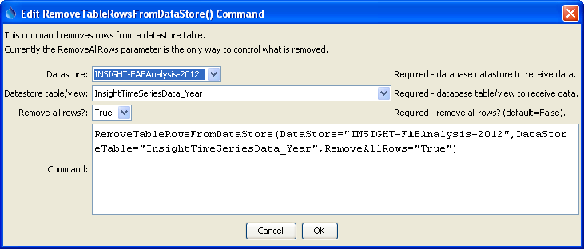
RemoveTableRowsFromDataStore
RemoveTableRowsFromDataStore() Command

The command syntax is as follows:

RemoveTableRowsFromDataStore(Parameter=Value,…)

Command Parameters
Parameter | Description | Default
DataStore | The name of a database datastore to process. | None – must be specified.
DataStoreTable | The name of the database table or view being processed. | None – must be specified.
RemoveAllRows | Indicate whether all rows should be removed (True) or only a subset (False). False is the default as a safeguard and future enhancements will enable removing only rows that match TSTool table rows or a constraint. | False – only rows matching TSTool table are removed.

