Command Reference: WriteTableToDelimitedFile()
Write a table to a delimited file
Version 10.13.00, 2012-10-03

The WriteTableToDelimitedFile() command writes a table to a delimited file. Currently only the comma is supported as the delimiter. This command is the analog to the ReadTableFromDelimitedFile() command. It can be used to provide tabular data to other programs, such as spreadsheet programs and geographic information systems.

The default is to write a standard file header using comment lines that start with the # character. If available, column names will be written in double quotes as the first non-comment row. Formatting for cell values is limited and the default precision of floating point numbers may include too many digits – this will be addressed in future updates.

The following dialog is used to edit the command and illustrates the syntax for the command.

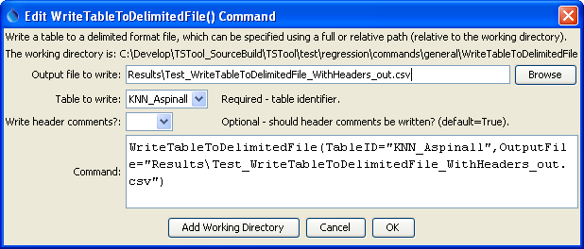
WriteTableToDelimitedFile
WriteTableToDelimitedFile() Command Editor

The command syntax is as follows:

WriteTableToDelimitedFile(Parameter=Value,…)

Command Parameters

Parameter | Description | Default
TableID | Identifier for the table to write. | None – must be specified.
OutputFile | The name of the file to write, as an absolute path or relative to the command file location. | None – must be specified.
WriteHeaderComments | Indicates whether to write the header comments, True or False. Some programs, such as Esri’s ArcGIS do not handle delimited files with comments. | True

