Command Reference: FillHistMonthAverage()
Fill missing time series data using historical monthly average data
Version 08.15.00, 2008-05-04

The FillHistMonthAverage() command fills missing data in monthly time series with the average monthly values. The average values are computed using the available data period (or specified averaging period – see the SetAveragePeriod() command) immediately after the time series is read and are then applied when this command is encountered.

The following dialog is used to edit the command and illustrates the syntax of the command.

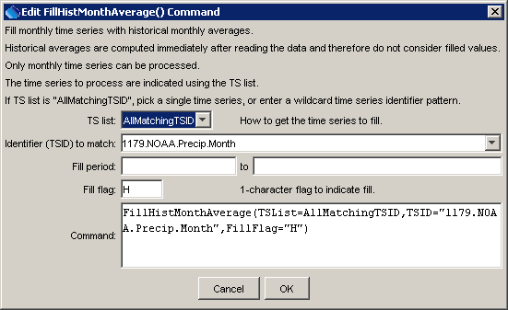
FillHistMonthAverage
FillHistMonthAverage() Command Editor

The command syntax is as follows:

FillHistMonthAverage(Parameter=Value,…)

Command Parameters

Parameter | Description | Default
TSList | Indicate how to determine the list of time series to process, one of:  - AllMatchingTSID – process time series that have identifiers matching the TSID parameter.  - AllTS – process all the time series.  - SelectedTS – process the time series that are selected (see selectTimeSeries()). | None – must be specified.
TSID | Used if TSList=AllMatchingTSID to indicate the time series identifier or alias for the time series to be filled. Specify * to match all time series or use a wildcard for one or more identifier parts. | Required if TSList=AllMatchingTSID.
FillStart | Date/time indicating the start of filling, using a precision appropriate for the time series, or OutputStart. | Fill the entire time series.
FillEnd | Date/time indicating the end of filling, using a precision appropriate for the time series, or OutputEnd. | Fill the entire time series.
FillFlag | If specified as a single character, data flags will be enabled for the time series and each filled value will be tagged with the specified character. The flag can then be used later to label graphs, etc. The flag will be appended to existing flags if necessary. | No flag is assigned.

The following command files fill a time series from the State of Colorado’s HydroBase:

# 0125 - ALAMOSA
0125.NOAA.Precip.Month~HydroBase
FillHistMonthAverage(TSList=AllMatchingTSID,TSID=”0125.NOAA.Precip.Month”,
FillFlag=”H”)

0125.NOAA.Precip.Month~HydroBase
FillHistMonthAverage(TSList=AllMatchingTSID,TSID=”019*”,FillFlag=”H”)

Time series data limits for the averages are printed to the log file, similar to the following examples (note that the period for averaging is always shown and may be different than the output period).

Status: Historic averages for time series follow...
Time series: 0125.NOAA.Precip.Month (IN)
Monthly limits for period 1948-08 to 1949-12 are:
# % # Not % Not
Month Min MinDate Max MaxDate Sum Miss. Miss. Miss. Miss. Mean
--------------------------------------------------------------------------------------------
Jan 0.2 1949-01 0.2 1949-01 0.2 0 0.00 1 100.00 0.2
Feb 0.1 1949-02 0.1 1949-02 0.1 0 0.00 1 100.00 0.1
Mar 0.1 1949-03 0.1 1949-03 0.1 0 0.00 1 100.00 0.1
Apr -999.0 -999.0 -999.0 1 100.00 0 0.00 -999.0
May -999.0 -999.0 -999.0 1 100.00 0 0.00 -999.0
Jun 0.7 1949-06 0.7 1949-06 0.7 0 0.00 1 100.00 0.7
Jul 1.5 1949-07 1.5 1949-07 1.5 0 0.00 1 100.00 1.5
Aug 0.7 1949-08 0.8 1948-08 1.5 0 0.00 2 100.00 0.8
Sep 0.1 1948-09 1.1 1949-09 1.2 0 0.00 2 100.00 0.6
Oct 0.1 1949-10 0.5 1948-10 0.7 0 0.00 2 100.00 0.3
Nov 0.0 1949-11 0.8 1948-11 0.8 0 0.00 2 100.00 0.4
Dec 0.0 1949-12 0.2 1948-12 0.2 0 0.00 2 100.00 0.1
--------------------------------------------------------------------------------------------
Period 0.0 1949-11 1.5 1949-07 6.9 2 11.76 15 88.24 0.5
--------------------------------------------------------------------------------------------

