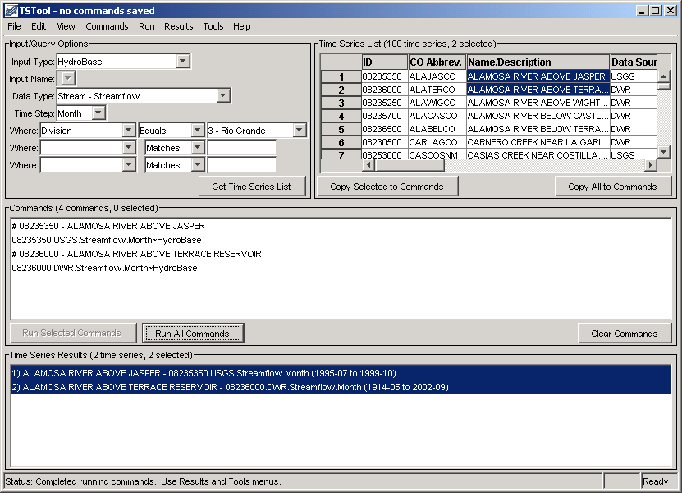
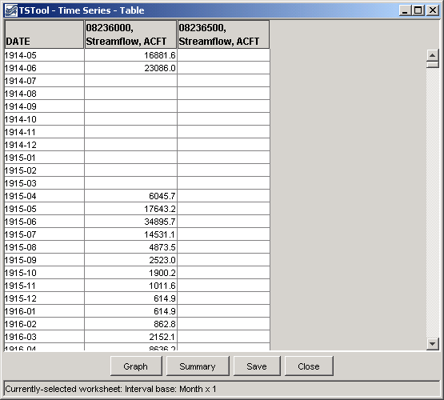
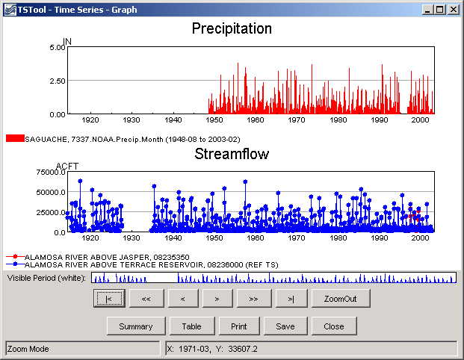
TSTool - Time Series Tool

Colorado Department of Natural Resources
Colorado Water Conservation Board
Division of Water Resources

Developed by:

 | Riverside Technology, inc.

Version 7.01.00, 2007-03-02

This page is intentionally blank.

This document is formatted for double-sided printing.

