Command Reference: add()
Add One or More Time Series to Another Time Series
Version 06.10.00, 2005-02-23, Color, Acrobat Distiller

The add() command adds regular interval time series. The receiving time series will be set to the sum of itself and all indicated time series. See also the newTimeSeries() command, which can create an empty time series to receive a sum. This command replaces the older add() command, which did not have the flag for how to handle missing data.

This command will generate an error if the time series do not have compatible units. If the units are compatible but are not the same (e.g., IN and FT), then the units of the part will be converted to the units of the sum before addition. Missing data in the parts can be ignored (do not set the sum to missing) or can result in missing values in the sum. The user should consider the implications of ignoring missing data. Time series being added must have the same data interval.

The following dialog is used to edit the command and illustrates the syntax of the command.

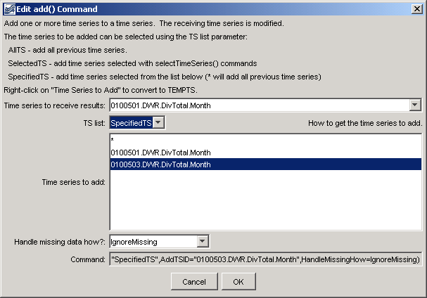
add
add() Command Editor

The command syntax is as follows:

add(param=value,…)

Command Parameters

Parameter | Description | Default
TSID | The time series identifier or alias for the time series to receive the sum. | None – must be specified.
TSList | Indicates how the list of time series is specified, one of:  - AllTS – all time series before the command.  - SelectedTS – the time series are those selected with the selectTimeSeries() command.  - SpecifiedTS – the specified list of time series given by the AddTSID parameter. | AllTS
AddTSID | If the TSList parameter is SpecifiedTS, provide the list of time series identifiers (or alias) to add. Right clicking on a time series allows toggling of the TEMPTS key word. This will cause the time series to add to be read and then discarded. | Must be specified if TSList=SpecifiedTS, ignored otherwise.
HandleMissingHow | Indicates how to handle missing data in a time series, one of:  - IgnoreMissing – create a result even if missing data are encountered in one or more time series – this option is not as rigorous as the others  - SetMissingIfOtherMissing – set the result missing if any of the other time series values is missing  - SetMissingIfAnyMissing – set the result missing if any time series value involved is missing | IgnoreMissing

A sample commands file is as follows:

# 0100501 - EMPIRE DITCH
0100501.DWR.DivTotal.Month~HydroBase
# 0100503 - RIVERSIDE CANAL
0100503.DWR.DivTotal.Month~HydroBase
add(TSID="0100501.DWR.DivTotal.Month",TSList="SpecifiedTS",
AddTSID="0100503.DWR.DivTotal.Month",HandleMissingHow=IgnoreMissing)

