Command Reference: addConstant()
Add a Constant Value to all Data Values in a Time Series
Version 06.08.02, 2004-08-02, Color, Acrobat Distiller

The addConstant() command adds a constant value to each data value in a time series within the specified period. This command is useful, for example, when a time series needs to be adjusted for a constant bias. Another example is to adjust a reservoir total volume time series by the dead pool storage in order to compute the active storage (or inverse). Missing data values will remain missing in the result.

The following dialog is used to edit the command and illustrates the syntax of the command.

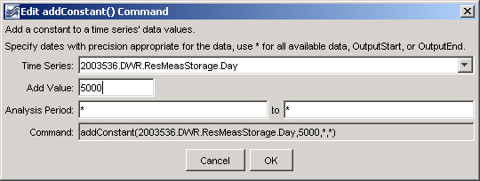
addConstant
addConstant() Command Editor

The command syntax is as follows:

addConstant(TSID,AddValue,AnalysisStart,AnalysisEnd)

Command Parameters

Parameter | Description | Default
TSID | The time series identifier or alias for the time series to be modified. | None – must be specified.
AddValue | The data value to add to the time series. | None – must be specified.
AnalysisStart | The date/time to start analyzing data. | Full period if * is specified.
AnalysisEnd | The date/time to end analyzing data. | Full period if * is specified.

A sample commands file is as follows:

# 2003536 - CONTINENTAL RES
2003536.DWR.ResMeasStorage.Day~HydroBase
addConstant(2003536.DWR.ResMeasStorage.Day,5000,*,*)

This page is intentionally blank.

