Command Reference: createFromList()
Create One or More Time Series from a List File
Version 06.08.02, 2004-07-29, Color, Acrobat Distiller

A createFromList() command can be inserted to create one or more time series using identifiers in a list file, an example of which is shown below:

# Example list file. Comments start with the # character.
500501
500502

This command can streamline processing in the following situations:

- A list of identifiers may have been generated from a database query and saved to a file.
- A list of identifiers may have been extracted from a model data set..

The following dialog is used to edit the command and illustrates the syntax of the command. TSTool reads the list file and internally creates a list of time series identifiers, using time series identifier information supplied by the createFromList() command. TSTool queries each time series, which can then be processed further.

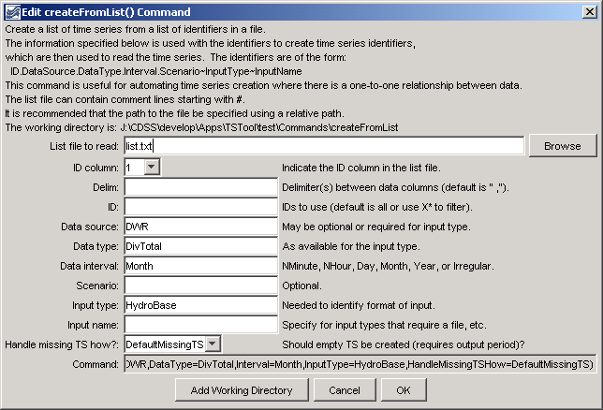
createFromList
createFromList() Command Editor

The command syntax is as follows:

createFromList(param=value,param=value,…)

Command Parameters

Parameter | Description | Default
ListFile | The name of the list file to read, surrounded by double quotes. | None – must be specified.
IDCol | The column (1+) in the list file containing the location identifiers to use in time series identifiers. | 1
Delim | The delimiter characters that separate columns in the list file. | Comma and space. If only a space is used, surround with another character that is unlikely to be found so that the space is not discarded as white space.
ID | Indicate a pattern to use filter the list of identifiers file. | Process all identifiers.
DataSource | The data source in the time series identifier, appropriate for InputType. | May or may not be required, depending on the input type. Refer to the input type appendices.
DataType | The data type in the time series identifier, as appropriate for InputType. | Usually required for an input type. Refer to the input type appendices.
Interval | Data interval in the time series identifier, using standard values. | None – must be specified.
Scenario | Scenario in the time series identifier. | Usually not required.
InputType | The input type in the time series identifier. | None – must be specified. Refer to the input type appendices.
InputName | The input name in the time series identifier. | Typically only required if the input type requires a file name.
HandleMissingTSHow | Indicates how to handle missing time series. | If set to DefaultMissingTS, time series that are not found will be initialized to missing data. If set to IgnoreMissingTS, time series will not be created.

A sample commands file is as follows:

# Read monthly diversion total from HydroBase for the structures in the list
# file. The data source is set to DWR because data source is saved in
# HydroBase.

createFromList(ListFile="list.txt",IDCol=1,DataSource=DWR,DataType=DivTotal,
Interval=Month,InputType=HydroBase,HandleMissingTSHow=DefaultMissingTS)

This command replaces the older -slist, -data_interval, and -data_type commands.

