Command Reference: deselectTimeSeries()
Deselect Time Series for Output
Version 06.08.02, 2004-08-03, Color, Acrobat Distiller

The deselectTimeSeries() command deselects output time series, as if done interactively. The command minimizes the need for the free() command, when used in conjunction with other commands that use a time series list based on selected time series. See also the selectTimeSeries() command. The following dialog is used to edit the command and illustrates the command syntax.

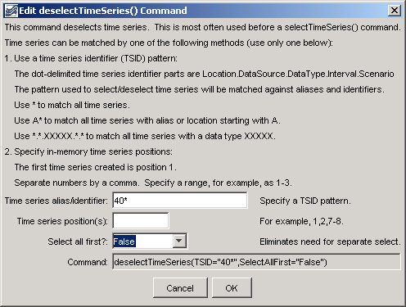
deselectTimeSeries
deselectTimeSeries() Command Editor

The command syntax is as follows:

deselectTimeSeries(param=value,…)

Command Parameters

Parameter | Description | Default
TSID | The time series identifier or alias pattern, to indicate time series to deselect. See the above figure for examples. | Can be blank if Pos is specified.
Pos | A list of time series positions in output (1+), separated by commas. This parameter is useful if it is known that the first time series is being modified by supbsequent commands. | Use the TSID.
SelectAllFirst | Indicates whether all time series should be selected before deselecting the specified time series: True or False. | False

A sample commands file is as follows:

deselectTimeSeries(TSID="40*",SelectAllFirst=True)

