Command Reference: fillFromTS()
Fill Missing Time Series Data Using Data From Another Time Series
Version 06.08.02, 2004-07-29, Color, Acrobat Distiller

The fillFromTS() command fills missing data in a time series by transferring non-missing values from another time series. This is useful when two time series typically have very similar values. The filled time series is not automatically extended. An analysis period can be specified to limit the period that is checked for missing data. See also the setFromTS() command, which will transfer all values. The following dialog is used to edit the command and illustrates the command syntax.

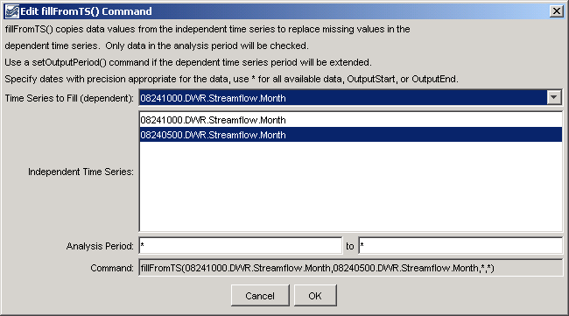
fillFromTS
fillFromTS() Command Editor

The command syntax is as follows:

fillFromTS(TSID,IndependentTSID,FillStart,FillEnd)

Command Parameters

Parameter | Description | Default
TSID | The time series identifier or alias for the time series to be filled. | None – must be specified.
IndependentTSID | The time series identifier or alias for the independent time series, to supply data. | None – must be specified.
FillStart | The date/time to start filling, if other than the full time series period. | Full period, if * is specified.
FillEnd | The date/time to end filling, if other than the full time series period. | Full period, if * is specified.

A sample commands file is as follows:

#
# 08241000 - TRINCHERA CREEK ABOVE MOUNTAIN HOME RESERVOIR
08241000.DWR.Streamflow.Month~HydroBase
# 08240500 - TRINCHERA CREEK ABOVE TURNER'S RANCH
08240500.DWR.Streamflow.Month~HydroBase
fillFromTS(08241000.DWR.Streamflow.Month,08240500.DWR.Streamflow.Month,*,*)

