Command Reference: fillPattern()
Fill Missing Time Series Data Using Historical Average Patterns
Version 06.10.00, 2005-04-27, Color, Acrobat Distiller

The fillPattern()fills missing data in a time series using historic averages based on a pattern file. For example, if May 1910 is missing and the pattern indicates that May 1910 is a WET month, then the average of all WET Mays is used to fill the time series. The pattern file indicates the WET/DRY/AVG patterns and the time series to be filled supplies data to compute averages, for use in filling. This feature is enabled for monthly data only. Averages are computed as described for the fillHistMonthAverage() command. There is currently no way to limit the fill operation to a period (the entire time series is filled). This command works in conjunction with the setPatternFile() command. See below for an example of a fill pattern file. One or more patterns can be included in each pattern file, similar to StateMod time series files (see the StateMod Input Type appendix), and multiple pattern files can be used, if appropriate.

# Years Shown = Water Years
# Missing monthly data filled by the Mixed Station Method, USGS 1989
# Time series identifier = 09034500.CRDSS_USGS.QME.MONTH.1
# Description = COLORADO RIVER AT HOT SULPHUR SPRINGS, CO.
# -e-b----------eb------eb------eb------eb------eb------eb------eb------eb------eb------eb------eb------eb------eb--------e
10/1908 - 9/1996 ACFT WYR
1909 09034500 AVG AVG AVG WET WET AVG AVG AVG WET WET WET WET
1910 09034500 WET WET WET WET WET WET AVG AVG AVG AVG AVG AVG
1911 09034500 AVG AVG WET AVG AVG AVG AVG WET WET WET AVG WET
1912 09034500 WET WET WET WET WET AVG AVG WET WET WET WET WET
...ommitted...

The following dialog is used to edit the fillPattern() command and illustrates the syntax of the command.

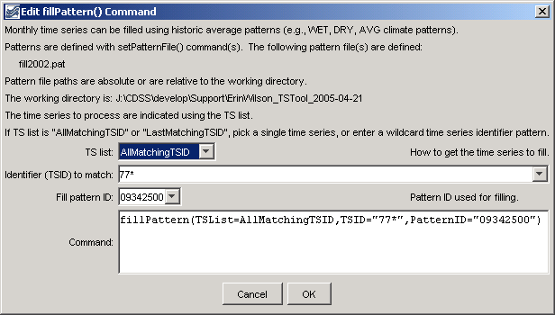
fillPattern
fillPattern() Command Editor
The command syntax is as follows:

fillPattern(param=value,…)

The obsolete syntax is as follows:

fillPattern(TSID,PatternID)

Command Parameters

Parameter | Description | Default
TSList | Indicate how the list of time series to process should be determined, one of:  - AllTS – all time series  - AllMatchingTSID – all time series that have identifiers matching the given TSID parameter.  - LastMatchingTSID – only the last time series matching the given TSID parameter  - SelectedTS – all time series that have been selected with selectTimeSeries() commands. | None – must be specified. For old syntax, AllMatchingTSID will be used if TSID contains wildcards or LastMatchingTSID if TSID is specified without wildcards.
TSID | The time series identifier or alias for the time series to be filled. A pattern containing the * wildcard character can be used to process multiple time series (e.g., * or 29*). | Must be specified if the TSList parameter has a value of AllMatchingTSID or LastMatchingTSID.
PatternID | The pattern identifier, matching a pattern read from the file(s) specified with setPatternFile() commands. | None – must be specified.

A sample commands file is as follows:

# Read the time series to fill…
readStateMod(..\StateMod\sjm_prelim.ddh)
# Read the file containing pattern data…
setPatternFile("fill.pat")
# Fill time series with identifiers starting with “30”, using
# the specified pattern…
fillPattern(TSList=AllMatchingTSID,TSID=”30*”,PatternID=”09034500”)
# Write the results…
writeStateMod("..\StateMod\sjm.ddh",*)

The above example fills all diversion time series with identifier starting with 30, using the pattern 09034500 (a stream gage for the region).

