Command Reference: fillRepeat()
Fill Missing Time Series Data by Repeating Known Data Values
Version 06.08.02, 2004-07-29, Color, Acrobat Distiller

The fillRepeat() command fills missing data in time series by repeating observations until another observation is found. This fill technique is useful, for example, where time series are likely to be step-wise or nearly constant, such as some reservoir and diversion time series. The following dialog is used to edit the command and illustrates the syntax of the command.

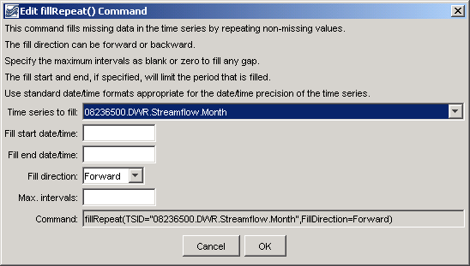
fillRepeat
fillRepeat() Command Editor

The command syntax is as follows:

fillRepeat(param=value,…)

Command Parameters

Parameter | Description | Default
TSID | The time series identifier or alias for the time series to be filled. Specify as * to fill all time series. | None – must be specified.
FillStart | The starting date/time for the fill. | Available period.
FillEnd | The ending date/time for the fill. | Available period.
FillDirection | Specify the direction of the fill as Forward or Backward. | Forward
MaxIntervals | The maximum number of intervals to fill in a data gap. | Fill entire gap.

A sample commands file is as follows:

# 08236500 - ALAMOSA RIVER BELOW TERRACE RESERVOIR
08236500.DWR.Streamflow.Month~HydroBase
fillRepeat(TSID="08236500.DWR.Streamflow.Month",FillDirection=Forward)

