Command Reference: free()
Free Time Series From Memory
Version 06.08.02, 2004-08-02, Color, Acrobat Distiller

The free() command frees the memory for the indicated time series. The time series will therefore not be available for use after that line in the commands file. This command is useful for discarding temporary time series needed for data manipulation (e.g., so that they are not written in output).

Rather than freeing time series, it may be more appropriate to use the selectTimeSeries() command, which can be used in conjunction with some commands to select time series and then operate on the selected time series. This approach allows selective use of time series and minimized the need for free() commands.

The following dialog is used for editing the command and illustrates the command syntax.

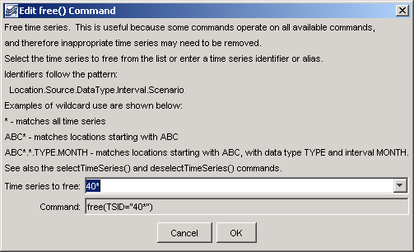
free
free() Command Editor

The command syntax is as follows:

free(TSID)

Command Parameters

Parameter | Description | Default
TSID | The time series identifier or alias for the time series to be freed. Specific time series can be specified or the identifier can contain wildcards to match patterns in time series identifiers (see figure above). | None – must be specified.

A sample commands file is as follows:

free(TSID="40*")

