Command Reference: newEndOfMonthTSFromDayTS()
Use a Daily Time Series to Create an End of Month Time Series
Version 06.08.02, 2004-07-29, Color, Acrobat Distiller

The newEndOfMonthTSFromDayTS() command replaces the older and more specific day_to_month_reservoir() command, and can be used to convert a daily reservoir storage time series to an end of month reservoir storage time series. The command can be applied to other data types (e.g., measured well levels).

Changing from a daily to an end of month monthly time series is accomplished by starting on the month ending day and searching in both directions for a daily measurement. It is possible that no value will be found for a particular month, with the given restraints. In this case, other fill commands (e.g., fillInterpolate()) can be applied to estimate the remaining missing data. The following dialog is used to edit the command and illustrates the syntax of the command.

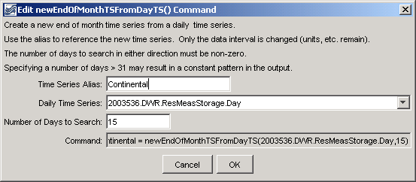
TS_newEndOfMonthTSFromDayTS
newEndOfMonthTSFromDayTS() Command Editor

The command syntax is as follows:

TS X = newEndOfMonthTSFromDayTS(TSID,Bracket)

Command Parameters

Parameter | Description | Default
X | The alias for the new time series. | None – must be specified.
TSID | The time series identifier or alias of the daily time series to be searched for data. | None – must be specified.
Bracket | The number of days to search from the end of the month, in order to find a daily value to transfer to the end of the month. | None – must be specified.

A sample commands file for estimating reservoir contents is:

# 2003536 - CONTINENTAL RES
2003536.DWR.ResMeasStorage.Day~HydroBase
TS Continental = newEndOfMonthTSFromDayTS(2003536.DWR.ResMeasStorage.Day,15)

A sample commands file for estimating well levels is:

# 2006000 - 80CW100 WELL FWS23-20A
2006000.USGS.WellLevel.Day~HydroBase
TS WellMonth = newEndOfMonthTSFromDayTS(2006000.USGS.WellLevel.Day,30)
fillInterpolate(WellMonth,0,Linear)

To evaluate the results of this command, it is useful to graph both the input and results, changing the graph properties to add symbols to see the individual measurements, as shown in the following figure.

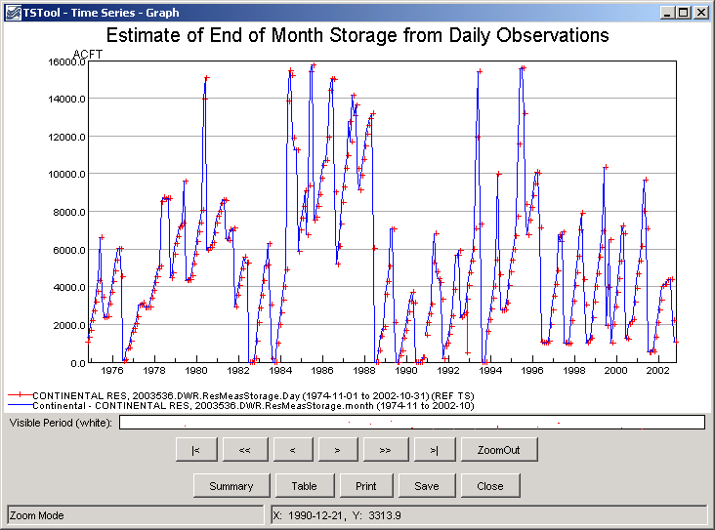
newEndOfMonthTSFromDayTS_Graph
Results of newEndOfMonthTSFromDayTS() Command

This page is intentionally blank.

