Command Reference: TS Alias = normalize()
Create a normalized time series
Version 06.10.08, 2005-09-22, Color, Acrobat Distiller

A normalize() command can be inserted to create a new normalized time series from an existing time series, assigning an alias to the result. Normalized time series are useful for analyzing trends and relationships and for allowing time series with different units to be plotted or analyzed together. The alias that is assigned to the time series can be referenced by other commands. The following dialog is used to edit the command and illustrates the syntax of the command.

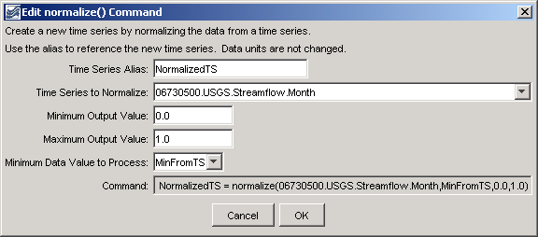
normalize
normalize() Command Editor

The command syntax is as follows:

TS Alias = normalize(TSID,MinValue,MaxValue,MinValueHow)

Command Parameters

Parameter | Description | Default
X | The alias for the new time series. | None – must be specified.
TSID | The time series identifier or alias for the time series to be normalized. | None – must be specified.
MinValue | The minimum normalized value. | None – must be specified.
MaxValue | The maximum normalized value. | None – must be specified.
MinValueHow | Indicates how to determine the minimum data value to process:  - MinFromTS – get the minimum value from the time series (typical)  - MinZero – use zero (e.g., if negative values are to be ignored) | None – must be specified.

A sample commands file is as follows:

# 06730500 - BOULDER CREEK AT MOUTH, NEAR LONGMONT, CO.
06730500.USGS.Streamflow.Month~HydroBase
TS NormalizedTS = normalize(06730500.USGS.Streamflow.Month,MinFromTS,0.0,1.0)

The results are as follows:

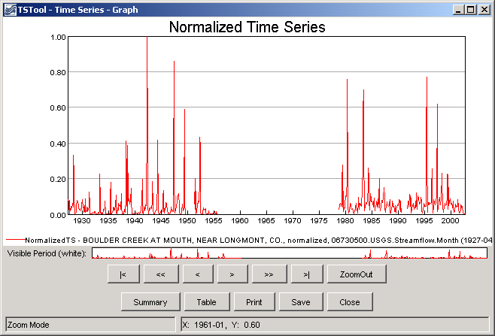
normalize_Graph
Results of normalize() Command

