Command Reference: TS X = readMODSIM()
Read a single time series from a MODSIM output file
Version 06.10.08, 2005-09-22, Color, Acrobat Distiller

The TS Alias = readMODSIM() command reads a single time series from a MODSIM file (see the MODSIM Input Type Appendix) and assigns an alias to the result. This command should not be confused with the readMODSIM() command that does not use the alias, which reads all time series in a MODSIM file.

The following dialog is used to edit the command and illustrates the syntax. When a file is selected, the available data types are listed, based on the file extension (the types are not read from the file).

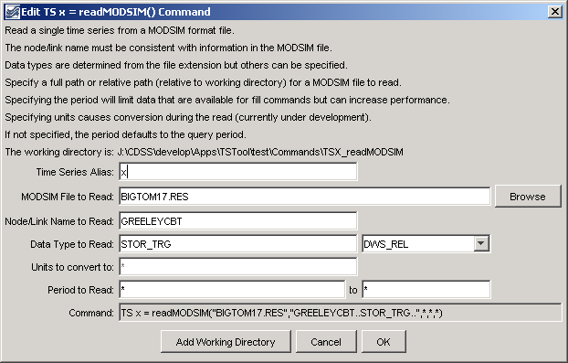
TS_readMODSIM
TX Alias = readMODSIM() Command Editor

The command syntax is as follows:

TS Alias = readMODSIM(InputFile,TSID,NewUnits,InputStart,InputEnd)

Command Parameters

Parameter | Description | Default
Alias | Alias for the new time series that is read from the file, which can be used instead of the TSID in other commands. | None – must be specified.
InputFile | The name of the MODSIM file to read, surrounded by double quotes. The path to the file can be absolute or relative to the working directory. The Browse button can be used to select the file to read (if a relative path is desired, remove the leading path after the select). | None – must be specified.
TSID | A time series identifier pattern to filter the read – this is constructed in the editor dialog from individual identifier parts – the location and data type are specified and used in the time series identifier. | None – must be specified.
NewUnits | The new units for the time series. The data values will be converted to these units. | Use the units read from the file.
InputStart | The start of the period to read data – specify if the period should be different from the global query period. | Use the global query period.
InputEnd | The end of the period to read data – specify if the period should be different from the global query period. | Use the global query period.

A sample commands file is as follows:

TS x = readMODSIM("BIGTOM17.RES","GREELEYCBT..STOR_TRG..",*,*,*)

