Command Reference: readNWSRFSESPTraceEnsemble()
Read all Time Series Traces from an NWSRFS ESP Trace Ensemble File
Version 06.08.02, 2004-07-29, Color, Acrobat Distiller

The readNWSRFSESPTraceEnsemble() command reads all the time series traces in an NWSRFS ESP Trace Ensemble file into memory (see the NWSRFS ESP Trace Ensemble Input Type Appendix). The actual reading occurs as the commands are being processed. Therefore, if any other commands reference the NWSRFS ESP Trace Ensemble time series, time series identifiers will need to be specified manually (they are not available to list in dialogs like other time series specified with identifiers) or use wildcards in identifiers. Currently, only conditional (CS) files may be read. Each trace is converted to a separate time series, with each having the same header information. The sequence number in the time series is set to the historical year for the start of the trace. The following dialog is used to edit the command and illustrates the syntax for the command.

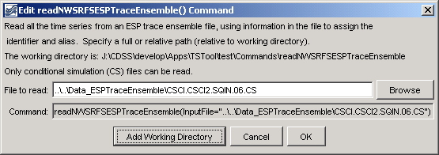
readNWSRFSESPTraceEnsemble
readNWSRFSESPTraceEnsemble() Command Editor

The command syntax is as follows:

readNWSRFSESPTraceEnsemble(param=value,…)

Command Parameters

Parameter | Description | Default
InputFile | The name of the DateValue input file to read, surrounded by double quotes. The path to the file can be absolute or relative to the working directory. The Browse button can be used to select the file to read (if a relative path is desired, remove the leading path after the select). | None – must be specified.

A sample commands file is as follows:

readNWSRFSESPTraceEnsemble(InputFile="..\..\Data_ESPTraceEnsemble\CSCI.CSCI2.SQIN.06.CS")

This page is intentionally blank.

