Command Reference: readStateCU()
Read all the Time Series from a StateCU Time Series or Report File
Version 06.08.02, 2004-07-29, Color, Acrobat Distiller

The readStateCU() command reads all the time series in a StateCU time series file (e.g., frost dates) or report file (e.g., IWR, WSL) into memory (see the StateCU Input Type Appendix). The actual reading occurs as the commands are being processed. Therefore, if any other commands reference the StateCU time series, the time series identifiers must be specified manually or use wildcards in identifiers (identifiers are not available to list in dialogs like other time series specified with identifiers). The following dialog is used to edit the command and illustrates the syntax for the command.

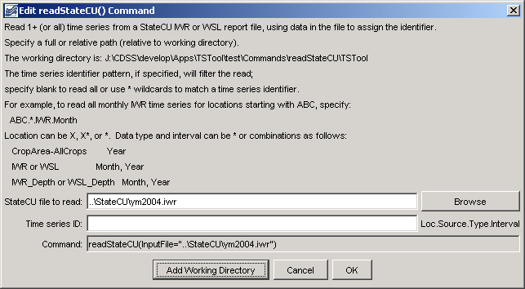
readStateCU
readStateCU() Command Editor

The command syntax is as follows:

readStateCU(param=value,…)

Command Parameters

Parameter | Description | Default
InputFile | The name of the StateCU time series or report file to read, surrounded by double quotes. The path to the file can be absolute or relative to the working directory. The Browse button can be used to select the file to read (if a relative path is desired, remove the leading path after the select). | None – must be specified.
TSID | A time series identifier pattern that will be used to filter the list of time series that are read. See the figure above for examples. | Read all time series.

A sample commands file is as follows:

readStateCU("..\StateCU\ym2004.iwr")

