Command Reference: TS X = readTimeSeries()
Read a Single Time Series from an Input Type
Version 06.08.02, 2004-07-29, Color, Acrobat Distiller

The TS X = readTimeSeries() command is used to read a single time series from any input type. This generalized command is useful for converting time series identifiers from the TSTool interface into read commands that assign an alias to a time series. Because the command is generic, it does not offer specific parameters that may be found in read commands for specific input types. Use the specific read commands where available. The following dialog is used to edit the command and illustrates the syntax of the command.

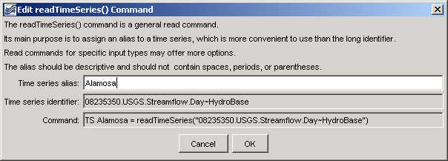
TS_readTimeSeies
readTimeSeries() Command Editor

The command syntax is as follows:

TS X = readTimeSeries(“TSID”)

Command Parameters

Parameter | Description | Default
X | The alias assigned to the time series. | None – must be specified.
TSID | The time series identifier of the time series to read. The identifier should include the input type (and input name) if required. See the input type appendices for examples of time series identifiers for various input types. | None – must be specified.

A sample commands file is as follows:

TS Alamosa = readTimeSeries("08235350.USGS.Streamflow.Day~HydroBase")

This page is intentionally blank.

