Command Reference: replaceValue()
Replace a Range of Data Values with a Constant Value
Version 06.08.02, 2004-08-02, Color, Acrobat Distiller

The replaceValue() command replaces a range of values in a time series with a constant value. The following dialog is used to edit the command and illustrates the syntax of the command:

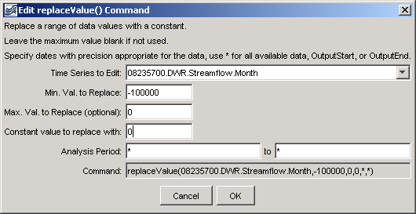
replaceValue
replaceValue() Command Editor

The command syntax is as follows:

replaceValue(TSID,MinValue,MaxValue,NewValue,
AnalysisStart,AnalysisEnd)

Command Parameters

Parameter | Description | Default
TSID | The time series identifier or alias for the time series to be modified. A single time series or all (*) can be specified. | None – must be specified.
MinValue | The minimum value to replace. | None – must be specified.
MaxValue | The maximum value to replace. | If not specified, only data values that exactly match the minimum value will be replaced.
NewValue | The new data value. | None – must be specified.
AnalysisStart | The date/time to start filling, if other than the full time series period. Specify as * to process the full period. | None – must be specified.
AnalysisEnd | The date/time to end filling, if other than the full time series period. Specify as * to process the full period. | None – must be specified.

A sample commands file is as follows:

# 08235700 - ALAMOSA RIVER BELOW CASTLEMAN GULCH NEAR JASPER
08235700.DWR.Streamflow.Month~HydroBase
replaceValue(08235700.DWR.Streamflow.Month,-100000,0,0,*,*)

