Command Reference: runCommands()
Run a commands file
Version 06.18.00, 2006-05-09, Color, Acrobat Distiller

The runCommands() command runs a commands file. This command can be used to manage workflow where multiple commands files are run, and is also useful for testing.

Commands files that are run CANNOT themselves include runCommands() commands. There is currently no special handling of log files; consequently, if the main commands file opens a log file and then a commands file is run that opens a new log file, the main log file will be closed. This behavior is being evaluated.

The working directory is reset to that of the commands file being run. This allows a master commands file to reside in a different location than the individual commands files that are being run.

The following dialog is used to edit the command and illustrates the syntax for the command.

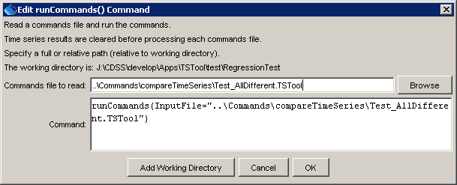
runCommands
runCommands() Command Editor

The command syntax is as follows:

runCommands(param=value,…)

Command Parameters

Parameter | Description | Default
InputFile | The name of the commands file to be run, enclosed in double quotes if the file contains spaces or other special characters. A path relative to the master commands file can be specified. | None – must be specified.
AppendResults | Indicate whether time series results from each commands file should be appended to the overall time series results. This parameter currently always defaults to False, but support for True may be implemented in the future. Consequently, only the time series results from the last commands file that is run will be displayed in TSTool. | Currently always False

The following example illustrates how the runCommands() command can be used to test TSTool software. First, individual commands files are implemented to test specific functionality, which will result in warnings if a test fails:

# Commands file to make sure that warnings are generated for different data.
readDateValue("RawData1.dv")
readDateValue("RawData1Scaled.dv")
# Generate an error if the files are the same.
# Since the files are different this would indicate a coding error.
compareTimeSeries(WarnIfSame=True)

Next, use the runCommands() command to run one or more tests:

# startLog(LogFile="Regression.log",Suffix="Date")
runCommands(InputFile="..\Commands\compareTimeSeries\Test_AllDifferent.TSTool")
runCommands(InputFile="..\Commands\compareTimeSeries\Test_AllSame.TSTool")
runCommands(InputFile="..\Commands\readHydroBase\2000812.TSTool")
runCommands(InputFile="..\Commands\readHydroBase\2002029.TSTool")

Each of the above commands files should produce expected time series results, without warnings. If any commands file unexpectedly produces a warning, a warning will also be visible in TSTool. The issue can then be evaluated to determine whether a software or configuration change is necessary.

