Command Reference: runningAverage()
Convert Time Series Data to Running Average Values
Version 06.08.02, 2004-08-03, Color, Acrobat Distiller

The runningAverage() command converts a time series’ raw data values to a running average, resulting in data that are smoothed. There are two versions of the command. The centered running average requires that the number intervals on each site of a point be specified (e.g., specifying 1 will average 3 values at each point). The N-year running average is computed by averaging the current year and N - 1 values on previous years, for a specific date. An average value is produced only if the needed number of non-missing values is available.

The following dialog is used to edit the command and illustrates the centered running average command syntax.

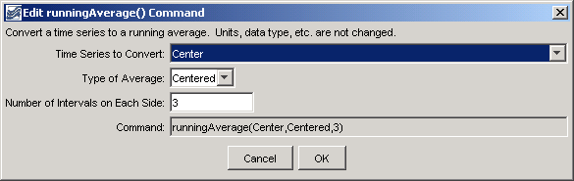
runningAverage_centered
runningAverage() Command Editor for Centered Running Average

The following dialog illustrates the N-year running average command syntax.

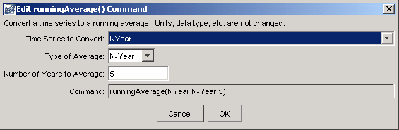
runningAverage_nyear
runningAverage() Command Editor for N-Year Running Average

The command syntax is as follows:

runningAverage(TSID,AverageMethod,Bracket)

Command Parameters

Parameter | Description | Default
TSID | The time series identifier or alias for the time series to be modified. A specific time series or all time series (*) can be converted to running averages. | None – must be specified.
AverageMethod | The method used to create the running average, one of:  - Centered – values on each side of a date/time are averaged.  - N-Year – values for the current year and (N – 1) preceding years, for the same date/time, are averaged. | None – must be specified.
Bracket | For centered running average, the bracket is the number of points on each side of the current point (therefore a value of 1 will average 3 data values). For N-year running average, the bracket is the total number of years to average, including the current year. | None – must be specified.

A sample commands file is as follows:

# 0100501 - EMPIRE DITCH
TS Center = readTimeSeries("0100501.DWR.DivTotal.Month~HydroBase")
runningAverage(Center,Centered,3)
TS NYear = readTimeSeries("0100501.DWR.DivTotal.Month~HydroBase")
runningAverage(NYear,N-Year,5)
0100501.DWR.DivTotal.Month~HydroBase

The resulting graph is as follows:

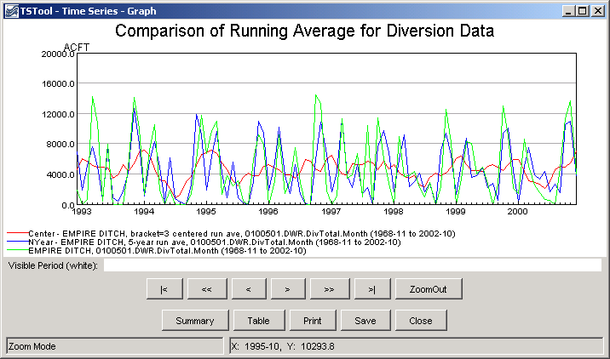
runningAverage_graph
Results from runningAverage() Commands

This page is intentionally blank.

