Command Reference: setConstant()
Set Time Series Data to a single or monthly constant values
Version 06.08.02, 2004-08-12, Color, Acrobat Distiller

The setConstant() command sets the values of a time series to a single or monthly constant values. The following dialog is used to edit the command and illustrates the command syntax:

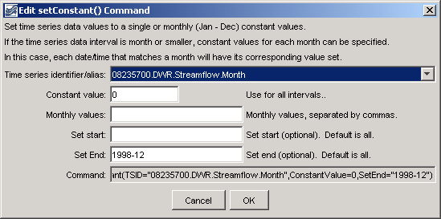
setConstant
setConstant() Command Editor

An example for setting only the June and July values is shown in the following figure:

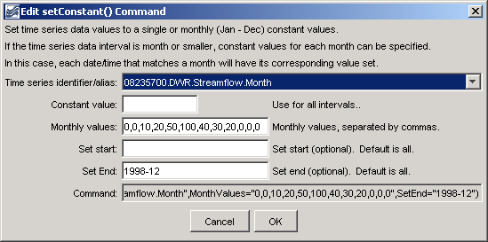
setConstant_month
setConstant() Command Editor, for Monthly Values
The command syntax is as follows:

setConstant(param=value,…)

Command Parameters

Parameter | Description | Default
TSID | The time series identifier or alias for the time series to be modified. A single time series or all (*) can be specified. | None – must be specified.
ConstantValue | The constant value to use as the data value. | None – must be specified, or specify monthly values.
MonthValues | Monthly values to use as the data values. Twelve values can be specified, separated by commas. If the time series data interval is less than monthly, each date/time will be set for a specific month. | None – must be specified, or specify a constant value.
SetStart | The starting date/time for the data set. | Set data for the full period.
SetEnd | The ending date/time for the data set. | Set data for the full period.

A sample commands file is as follows:

# 08235700 - ALAMOSA RIVER BELOW CASTLEMAN GULCH NEAR JASPER
08235700.DWR.Streamflow.Month~HydroBase
setConstant(TSID="08235700.DWR.Streamflow.Month",ConstantValue=0,SetEnd="1998-12")

