Command Reference: setConstantBefore()
Set time series data to a constant value on and before a specified date/time
Version 06.08.02, 2004-08-12, Color, Acrobat Distiller

The setConstantBefore() command sets the values of a time series to a constant value, on and before a specified date/time. This is useful, for example, to remove the effects of a reservoir from a system, before it was in place. This command is obsolete. For equivalent functionality, use setConstant() and specify only the end date.

The following dialog is used to edit the command and illustrates the command syntax.

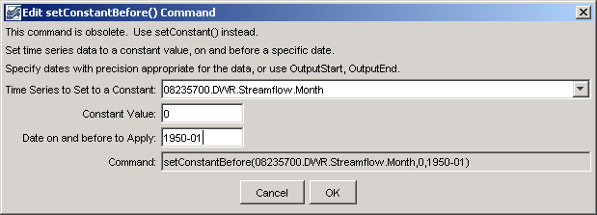
setConstantBefore
setConstantBefore() Command Editor

The command syntax is as follows:

setConstantBefore(TSID,ConstantValue,ConstantEnd)

Command Parameters

Parameter | Description | Default
TSID | The time series identifier or alias for the time series to be modified. A single time series or all (*) can be specified. | None – must be specified.
ConstantValue | The constant value to use as the data value. | None – must be specified.
SetEnd | The last date/time on which to apply the constant value. | None – must be specified.

A sample commands file is as follows:

# 08235700 - ALAMOSA RIVER BELOW CASTLEMAN GULCH NEAR JASPER
08235700.DWR.Streamflow.Month~HydroBase
setConstantBefore(08235700.DWR.Streamflow.Month,0,1950-01)

