Command Reference: setDataValue()
Set a Specific Time Series Data Value at a Date/Time
Version 06.08.02, 2004-08-02, Color, Acrobat Distiller

The setDataValue() command sets a single data value in a time series. Consequently, it can be used to condition filling or to "hard-code" data. The following dialog is used to edit the command and illustrates the syntax of the command. It is good practice to insert comments when editing data to explain the edits.

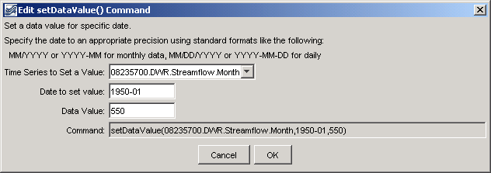
setDataValue
setDataValue() Command Editor

The command syntax is as follows:

setDataValue(TSID,DateTime,NewValue)

Command Parameters

Parameter | Description | Default
TSID | The time series identifier or alias for the time series to be modified. | None – must be specified.
DateTime | The date/time at which the data value should be set. Specify the date/time precision according to the time series that is being manipulated. | None – must be specified.
NewValue | The new data value. | None – must be specified.

A sample commands file is as follows:

# 08235700 - ALAMOSA RIVER BELOW CASTLEMAN GULCH NEAR JASPER
08235700.DWR.Streamflow.Month~HydroBase
setDataValue(08235700.DWR.Streamflow.Month,1950-01,550)

This page is intentionally blank.

