Command Reference: setIncludeMissingTS()
Indicate whether Missing Time Series Should be Added
Version 06.08.02, 2004-07-29, Color, Acrobat Distiller

The setIncludeMissingTS() command sets the global property that indicates whether time series that cannot be found should be added with missing data. By default, time series that cannot be found generate a warning. This command is useful when processing large amounts of data with wildcards, to guarantee a placeholder time series even if time series are not found. The following dialog is used to edit this command and illustrates the syntax of the command.

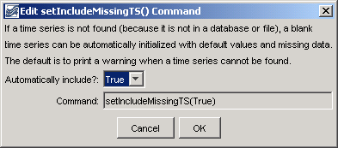
setIncludeMissingTS
setIncludeMissingTS() Command Editor

The command syntax is as follows:

setIncludeMissingTS(IncludeMissingTS)

Command Parameters

Parameter | Description | Default
IncludeMissingTS | Indicates whether time series that are not found with read commands should automatically be added with missing data. | If this command is not used, the default is False.

A sample commands file is as follows:

setIncludeMissingTS(True)

This page is intentionally blank.

