Command Reference: setPatternFile()
Set the Pattern File to be Used With fillPattern() Commands
Version 06.08.02, 2004-08-02, Color, Acrobat Distiller

The setPatternFile() command specifies a pattern file to be used with fillPattern() commands (see the fillPattern() command for more information ). This command replaces the older -filldata option. The following dialog is used to edit the command and illustrates the command syntax.

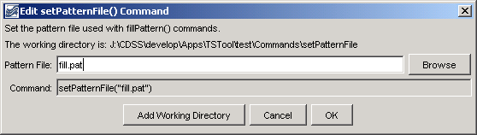
setPatternFile
setPatternFile() Command Editor

The command syntax is as follows:

setPatternFile(PatternFile)

Command Parameters

Parameter | Description | Default
PatternFile | The path to the pattern file, which can be absolute or relative to the working directory. The Browse button can be used to select the pattern file (if a relative path is desired, remove the leading path after the select). | None – must be specified.

A sample commands file is as follows:

setPatternFile("fill.pat")

This page is intentionally blank.

