Command Reference: setWarningLevel()
Set Level for Warning Messages
Version 06.08.02, 2004-08-03, Color, Acrobat Distiller

The setWarningLevel() command sets the warning levels for the screen and log file. This command can be used multiple times, for example to isolate a problem. The following dialog is used to edit this command and illustrates the command syntax.

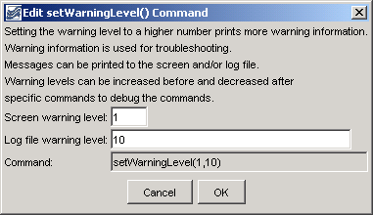
setWarningLevel
setWarningLevel() Command Editor

The command syntax is as follows:

setWarningLevel(ScreenLevel,LogFileLevel)

Command Parameters

Parameter | Description | Default
ScreenLevel | The warning level for the screen (0+). | None – must be specified. The default is warning level 1 to the screen and 2 to the log file.
LogFileLevel | The warning level for the log file (0+). | None – must be specified.

A sample commands file is as follows:

setWarningLevel(1,10)

This page is intentionally blank.

