Command Reference: shiftTimeByInterval()
Shift Time Series Data by One or More Time Intervals
Version 06.08.02, 2004-08-03, Color, Acrobat Distiller

The shiftTimeByInterval()command shifts a time series in time. This command can be used to perform a simple shift (e.g., to shift hourly data because the disaggregate() command did not result in data being set at the desired hours) and to perform simple routing. The following dialog is used to edit the command and illustrates the command syntax.

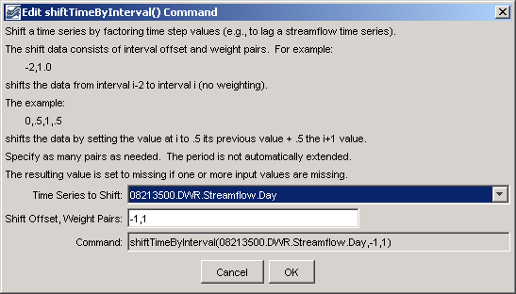
shiftTimeByInterval
shiftTimeByInterval() Command Editor

The command syntax is as follows:

shiftTimeByInterval(TSID,Interval,Multiplier,…)

Command Parameters

Parameter | Description | Default
TSID | The time series identifier or alias for the time series to be modified. | None – must be specified.
Interval | The interval to shift. For example, -1 indicates that the previous time step should be shifted to the current time step. Multiple Interval/Multiplier pairs can be specified. | None – at least 1 value must be specified.
Multiplier | The multiplier to apply to the value being shifted. For example, if the Interval is –1 and the Multiplier is 1, the previous time step is shifted to the current and multiplied by 1, effectively shifting the time series by one interval. | None – at least 1 value must be specified.

A sample commands file is as follows:

# 08213500 - RIO GRANDE RIVER AT THIRTY MILE BRIDGE NEAR CREEDE
08213500.DWR.Streamflow.Day~HydroBase
shiftTimeByInterval(08213500.DWR.Streamflow.Day,-1,1)
08213500.DWR.Streamflow.Day~HydroBase

The resulting graph is as follows:

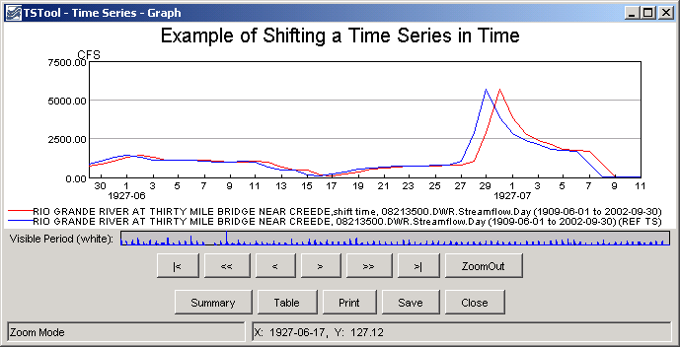
shiftTimeByInterval_graph
Results from shiftTimeByInterval() Command

