Command Reference: sortTimeSeries()
Sort the Time Series by their Identifiers
Version 06.10.00, 2005-05-22, Color, Acrobat Distiller

The sortTimeSeries() command sorts the time series alphabetically using the time series identifier. This command is useful for ordering time series before writing output, for example to facilitate comparison with another version of the output or to be consistent with other data files.

The following dialog is used to edit the command and illustrates the syntax for the command.

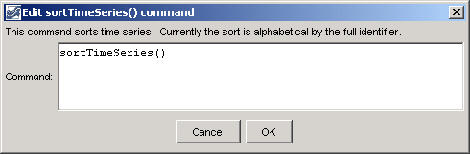
sortTimeSeries
sortTimeSeries() Command Editor

The command syntax is as follows:

sortTimeSeries(param=value,…)

Command Parameters

Parameter | Description | Default
 | Currently no parameters are available for this command.

A sample commands file is as follows:

sortTimeSeries()

This page is intentionally blank.

