Command Reference: statemodMax()
Compute the Maximum of Time Series in Two StateMod Files
Version 06.08.02, 2004-07-29, Color, Acrobat Distiller

A statemodMax() command performs the following actions:

- Read all time series from one StateMod time series file,
- Read all time series from a second StateMod time series file,
- Generate a list of time series in memory that contains the maximum values comparing matching time series (using the location identifier).

This command is useful, for example, when creating a demand time series file that is to be the maximum of historical diversions and IWR divided by an average efficiency. It is assumed that the specified time series have matching identifiers (the first file is used as the master list) and have consistent units and data intervals. After the time series have been processed, they can be viewed or written out as a new StateMod file (see the writeStateMod() command). The following dialog is used to edit the command and illustrates the syntax for the command.

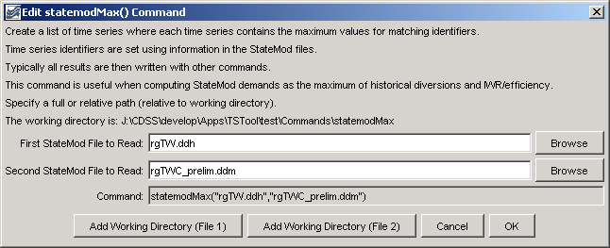
statemodMax
statemodMax() Command Editor

The command syntax is as follows:

statemodMax(InputFile1,InputFile2)

Command Parameters

Parameter | Description | Default
InputFile1 | The name of the first StateMod time series file to read, surrounded by double quotes. The path to the file can be absolute or relative to the working directory. The Browse buttons can be used to select the file to read (if a relative path is desired, remove the leading path after the select). | None – must be specified.
InputFile2 | The name of the second StateMod time series file to read, which must have the same data interval and units as the first file. | None – must be specified.

A sample commands file is as follows:

statemodMax("rgTW.ddh","rgTWC_prelim.ddm")
writeStateMod("rgTW.ddm",*)

