Appendix: TSTool Installation and Configuration for RiverTrak® and NWSRFS Systems
RTi Version, 07.00.00, 2007-01-23, Acrobat Distiller

1. Overview

This appendix describes how to install TSTool as part of RTi’s RiverTrak® System and to support the National Weather Service River Forecast System (NWSRFS). Using these instructions, TSTool can also be installed stand-alone (using the RiverTrak® System directory structure). TSTool can be installed on Windows and UNIX/Linux computers.

2. Installing TSTool

2.1 Installing TSTool in Support of a RiverTrak® System – Windows

Locations of TSTool software files are as follows (the _XXX notation indicates the JRE [Java Runtime Environment] version number, e.g., _142). Files are normally installed on the C: drive but can be installed in a shared location on a server.

\Program Files\RTi\RiverTrak\ |  | Top-level install directory.
bin\ |  | Software directory for TSTool.bat file and Java JAR files.
Blowfish_XXX.jar |  | Used for encryption/security.
HydroBaseDMI_XXX.jar |  | State of Colorado HydroBase database interface package.
msbase.jar  mssqlserver.jar  msutil.jar |  | Microsoft SQL Server packages (see special installation instructions below).
NWSRFS_DMI_XXX.jar |  | National Weather Service River Forecast System (NWSRFS) package.
RiversideDB_DMI_XXX.jar |  | Riverside Technology, inc., RiversideDB database package to support RiverTrak® systems.
RTi_Common_XXX.jar |  | Riverside Technology, inc. supporting packages.
shellcon.exe |  | Executable program used to read from the Windows registry (e.g., to determine the default web browser and list available ODBC data source names).
StateCU_XXX.jar |  | State of Colorado’s StateCU model package.
StateMod_XXX.jar |  | State of Colorado’s StateMod model package.
TSTool.bat |  | Batch file to run TSTool using the JRE software. You may need to edit this if the installation is not standard.
TSTool_XXX.bat |  | Same as TSTool.bat but indicates the JRE version that is compatible. Run this batch file directly if you need to run an older (_118) or newer (_142) version. The TSTool.bat file is a copy of the versioned file and is the copy that most users should run.
TSTool_XXX.jar |  | TSTool main application package.
doc\TSTool\UserManual\ |  | Main documentation directory for TSTool.
TSTool.pdf |  | TSTool documentation as PDF.
logs\ |  | Directory for TSTool log files (should be writable).
system\ |  | Directory for system files.
DATAUNIT |  | Data units file.
TSTool.cfg |  | Configuration file to modify TSTool defaults.
\Program Files\RTi\JRE_XXX\ |  | Java Runtime Environment (shared by the RiverTrak® system and other RTi software).

Use the following instructions to install TSTool using the TSTool_Setup.exe installer program.

- Run the TSTool_Setup.exe file by selecting from Windows Explorer, the Start… Run… menu, or from a command shell. The setup filename will include a version number (e.g., TSTool_RiverTrak_7.00.00_Setup.exe).

You must be logged into the computer using an account with administrator privileges. Otherwise, the following warning will be displayed:

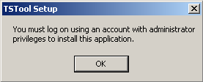
Install_AdministratorWarning

If you have administrative privileges, the following welcome will be displayed, and the installation can continue:

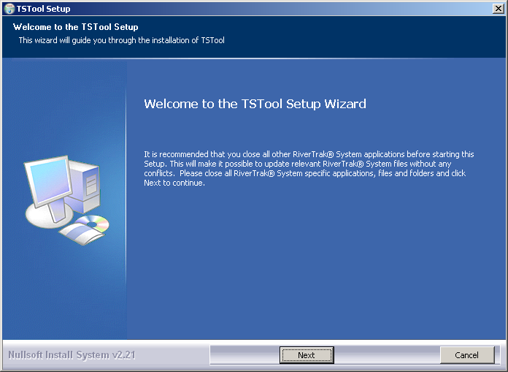
Install_Welcome

Press Next to continue with the installation.
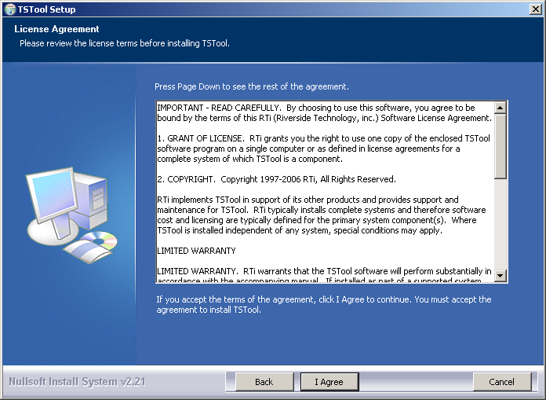
Install_Disclaimer

Press I Agree to continue with the installation.

- Several components can be selected for the install as shown in the following dialog. Position the mouse over a component to see its description.

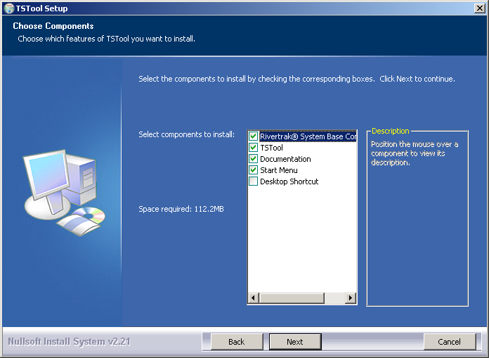
Install_SelectComponents

Select the components to install and press Next.

- The following dialog is then shown and is used to select the installation location for TSTool. To be consistent with other RiverTrak® System components, select the main RiverTrak System folder, as shown below. The following dialog will display the RiverTrak® System install location if the RiverTrak® System Base component has been previously installed:

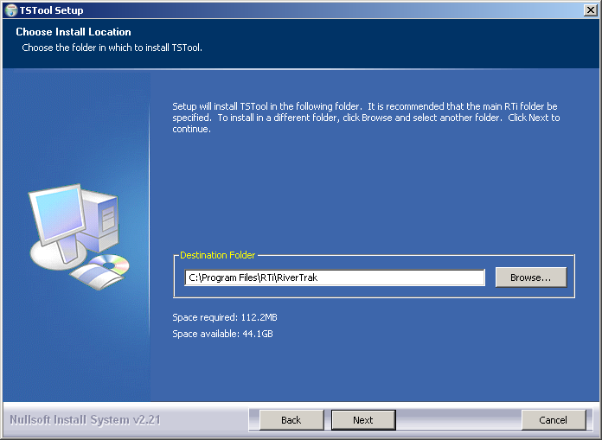
Install_SelectFolder

After selecting the install location, press Next.

Note that this location will be saved as a Windows registry setting (HKEY_LOCAL_MACHINE\Software\RTi\TSTool\…) to allow future updates to check for and default to the same install location, and to allow the standard software uninstall procedure to work correctly.

- The following dialog will be shown to select the menu for the software:

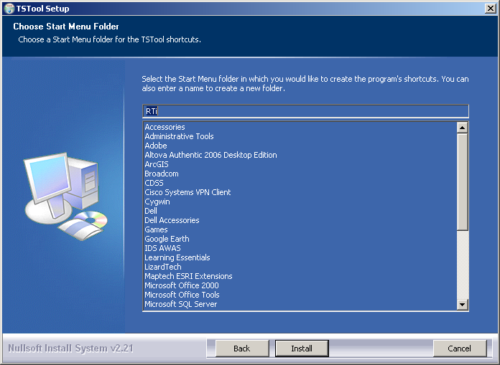
Install_StartMenuFolder

After selecting the folder, press Install.

- The following dialog will show the progress of the installation:

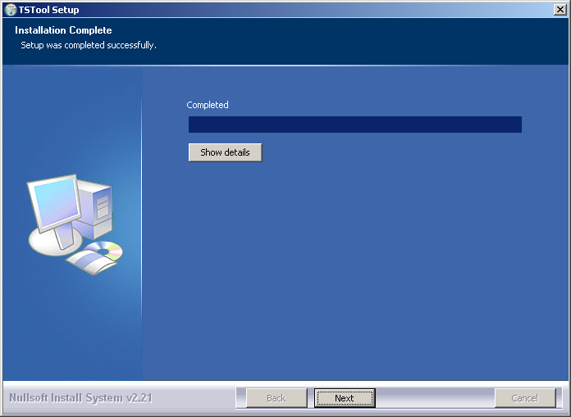
Install_Complete

Press Show details to see the files that were installed or press Next to continue.

- The following dialog will then be shown asking whether the TSTool software should be run:

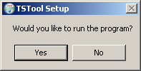
Install_RunTSToolQuestion

Press Yes to run the software or No to exit the installation procedure.

- A reboot is not required to use the software from the Start menu. However, a reboot may be required on some computers to run TSTool from the command line.
- The default TSTool_setup.exe file is distributed with a demo license. You may be instructed

2.1.1 Installing TSTool on a File Server

TSTool can be installed on a file server, which allows software updates to be made in one location, thereby eliminating the need to install software on individual machines. For this type of installation, all computers that access the software must have similar configuration, including network configuration. The standard installer described in this documentation focuses on individual installs on user computers. To make TSTool software installed on a server available to other computers, perform the following (this is typically performed by system administrators):

- Run the TSTool_Setup.exe installer as described above. During installation specify the RiverTrak® System home using a drive letter and path for the server or specify a Universal Naming Convention (UNC) path (e.g., \\RiverTrakSystemServer\Program Files\RTi\RiverTrak). All computers that will use the software will need to have access to the server in a consistent way because the TSTool software will expect the RiverTrak® System installation home at runtime to be that specified during the installation.
- The menus and shortcuts will only be configured for the computer from which the installation was run. Therefore, menus and shortcuts for other computers will need to be manually configured.

If TSTool has been installed on a local computer and it is also available on the network, the network version can be run by running the software in the NetworkRiverTrakInstallHome\bin folder. The software will expect that file locations use the same drives as when the software was installed.

2.1.2. Special Installation Instructions for Microsoft SQL Server Support

Complete this step if the TSTool software will use a SQL Server database (e.g., to interact with a RiversideDB database or the State of Colorado’s SQL Server HydroBase).

The free SQL Server driver from Microsoft is now being used for TSTool installations that use SQL Server. Note that using this driver is only allowed if you have purchased a copy of SQL Server for your organization. The TSTool software requires only the msbase.jar, mssqlserver.jar, and msutil.jar files from the Microsoft installation. However, Microsoft requires that you do a full installation of its driver in order to acknowledge the End User License Agreement (EULA). Because only three files listed previously are needed for TSTool Java software, it is recommended that the Microsoft install be completed once within an organization (to complete the EULA recognition), but then use the three files distributed with TSTool software as is (ignore the Microsoft installation). To perform the Microsoft installation, do one of the following:

- Contact the supplier of the TSTool software (Riverside Technology, inc.) to provide the Microsoft driver or have them help you install the driver. For software installations within an organization, this step need be done only once by an organization’s IT staff. All other TSTool users within an organization can then use the software using the three software files described above.

- Download and install the Microsoft JDBC driver from http://www.microsoft.com/sql/downloads and install according to its instructions. Do this if you have purchased SQL Server and will install a SQL Server version of a database supported as one of TSTool’s input types (e.g., RiversideDB or the State of Colorado’s HydroBase).

2.2. Installing TSTool in Support of a RiverTrak® System - Linux

Currently, an automated installation procedure is not available and the files should be installed manually by copying from a CD or installing from a zip file. These instructions are for Linux systems but the installation is similar for UNIX systems. Locations of TSTool software files are as follows (the _XXX notation indicates the JRE [Java Runtime Environment] version number, e.g., _142). Files are normally installed in /opt and this location is assumed in the file locations shown below.

/opt/RTi/RiverTrak/ |  | Top-level install directory.
bin/ |  | Software directory for TSTool.bat file and Java JAR files.
HydroBaseDMI_XXX.jar |  | State of Colorado HydroBase database interface package.
msbase.jar  mssqlserver.jar  msutil.jar |  | Microsoft SQL Server packages (see special installation instructions below).
NWSRFS_DMI_XXX.jar |  | National Weather Service River Forecast System (NWSRFS) package.
RiversideDB_DMI_XXX.jar |  | Riverside Technology, inc., RiversideDB database package to support RiverTrak® systems.
RTi_XXX.jar |  | Riverside Technology, inc. supporting packages.
StateCU_XXX.jar |  | State of Colorado’s StateCU model package.
StateMod_XXX.jar |  | State of Colorado’s StateMod model package.
tstool |  | Batch file to run TSTool using the JRE software. You may need to edit this if the installation is not standard.
tstool_XXX |  | Same as TSTool but indicates the JRE version that is compatible. Run this batch file directly if you need to run an older (_118) or newer (_142) version. The TSTool.bat file is a copy of the versioned file and is the copy that most users should run.
TSTool_XXX.jar |  | TSTool main application package.
doc/TSTool/UserManual/ |  | Main documentation directory for TSTool.
TSTool.pdf |  | TSTool documentation as PDF.
logs/ |  | Directory for TSTool log files (should be writable).
system/ |  | Directory for system files.
DATAUNIT |  | Data units file.
TSTool.cfg |  | Configuration file to modify TSTool defaults.
/opt/RTi/JRE_XXX |  | Java Runtime Environment (shared by the RiverTrak® system and other RTi software).
During installation, the above files should normally be copied from a CD. The logs directory is the only directory that should have write permissions when copied from a CD (read-only permissions are OK otherwise). The files in the system directory may have been customized in a previous installation and may need to be preserved in an update. Software files may be shared with other software components. Installing new software is generally safe because steps are taken to be backward compatible. However, care should be taken if installing an old version of software on a system where newer software may have been installed.

After copying software onto a computer, the following additional steps may be required.

- If necessary, edit the tstool file (and optionally the tstool_XXX files) to define proper settings for the system. Several parameters at the top of the file indicate directory locations.

- To run TSTool, run the /opt/RTi/RiverTrak/bin/tstool batch program. This will start the JRE, which runs TSTool.

- Modify the TSTool configuration files described at the end of this documentation. In particular, disable/enable input types appropriate for the system.

Warning: any files copied from a read-only CD will be read-only when installed. Most files can be read-only; however, the logs directory in particular should not be read-only.

2.3. Installing TSTool in Support of NWSRFS - Linux

If installing TSTool for an NWSRFS system (independent of a RiverTrak® System), substitute /opt/RTi/NWSRFS for the top-level installation directory (/opt/RTi/RiverTrak, as shown in the previous section).

The TSTool configuration on an NWSRFS system is similar to the normal configuration. When running on Linux, it is possible to use database input types that may be accessible on a database server. However, this is not the norm and therefore unused input types are usually disabled in the configuration file (see the TSTool Configuration Files section below).

3. Uninstalling TSTool Software

3.1 Uninstalling TSTool Software - Windows

To uninstall TSTool software, select RTi…Uninstall…TSTool from the Start menu and confirm the uninstall. RiverTrak® System components that are used by other software (e.g., RiverTrak® System Base component software) as well as user data will remain installed.

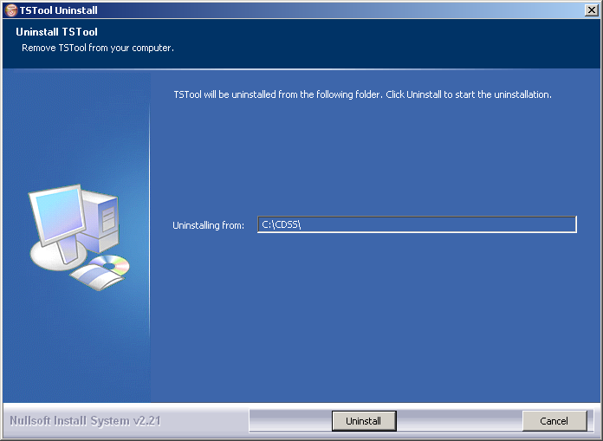

Press Uninstall to uninstall the software.

4. Running TSTool

TSTool can be started in several ways as described below.

4.1 RTi Menu

The Start…All Programs…RTi…TSTool (or Start… Programs… RTi… TSTool) menu can be used to start the software. This runs the RiverTrakInstallHome\bin\TSTool.exe software.

4.2 Command Line Executable

The installation process adds the RiverTrakInstallHome\bin folder to the path, allowing the TSTool software to be started anywhere by running TSTool. Running TSTool from any drive will result in the software being run in the installation location. Specifying a commands file on the command line or interactively will reset the working directory to that of the commands file.

4.3 TSTool Batch File

TSTool was previously started with and can still be run with the RiverTrakInstallHome\bin\TSTool.bat file, for example to support troubleshooting. In this case, the file name tstool.bat must be fully specified because running tstool will result in the executable program being run (see previous section).

5. TSTool Configuration Files

TSTool requires minimal configuration after installation. This section describes TSTool configuration files that can be customized for a system.

5.1 TSTool Configuration File

The system/TSTool.cfg file under the main installation directory contains top-level configuration information for TSTool. The format of the file is as follows:

# Configuration file for TSTool

[TSTool]

DateValueEnabled = true
HydroBaseEnabled = true
MexicoCSMNEnabled = true
NWSCardEnabled = true
NWSRFSFS5Files = true
NWSRFSESPTraceEnsembleEnabled = true
RiversideDBEnabled = true
RiverWareEnabled = true
StateCUEnabled = true
StateModEnabled = true

MapLayerLookupFile = "\cdss\gis\co\TimeSeriesMapLookup.csv"

LicenseOwner = "YourName"
LicenseType = Site
LicenseCount = 3
LicenseExpires = Never
LicenseKey = "your-key"

Example TSTool Configuration File

The example illustrates the format of the file. The *Enabled properties can be used to enable/disable input types. Common formats are enabled by default and more specialized formats are disabled by default, if not specified in the file. For example use HydroBaseEnabled = false to disable the automatic HydroBase login that occurs with the HydroBase input type (e.g., if HydroBase is unavailable for some reason). The license properties are assigned by RTi and should not normally be changed by TSTool users. Each input type can have additional properties, although only a few currently do, as described below.

The optional MapLayerLookupFile property indicates the name of the time series to map layer lookup file. See the Map Configuration section below.

5.2 Data Units File

The system/DATAUNIT file under the main installation directory contains data unit information that defines conversions and output precision. In most cases the default file can be used but additional units may need to be added for a user's needs (in this case please notify the developers so the units can be added to the default file distributed with installations). Currently the DATAUNIT file is the only source for units information – in the future units may be determined from the various input sources.

5.3 HydroBase Configuration

The following properties can be defined to control how TSTool interacts with HydroBase. See also the CDSS Configuration File section below.

TSTool HydroBase Configuration Properties

Property | Description | Default
WDIDLength | Indicates the length of water district identifiers (WDIDs) constructed from separate WD and ID data, when creating time series identifiers. Because time series identifier strings are compared literally, it is important that the WDIDs are consistent within a commands file. | 7

5.4 CDSS Configuration File

By default, TSTool will automatically look for HydroBase databases on the current (local) machine and the State servers. State server databases are typically only accessible to State of Colorado computers. If SQL Server or MSDE HydroBase versions have been installed on a different machine, the \cdss\system\CDSS.cfg file can be used to indicate the database servers. An example of the configuration file is as follows:

[HydroBase]

ServerNames="ServerName,local"
DefaultServerName="ServerName"
DefaultDatabaseName="HydroBase_CO_East_20050730"

[ColoradoSMS]

ServerNames="ServerName,local"
DefaultServerName="ServerName"
DefaultDatabaseName="RealtimeStreamflow"
UserLogin="UserLogin"

The ColoradoSMS input type is being used to support annotation of real-time data graphs with alert information. These features are under development.

Properties can be specified on the TSTool command line using the notation “Property=Value” and will in some cases override the values in the configuration file. These features are under development as necessary.

The CDSS configuration properties are described in the following tables:

CDSS HydroBase Database Configuration Properties

Property | Description | Default
ServerNames | A comma-separated list of server names to list in the HydroBase login dialog. | The state server is listed.
Default  ServerName | The default HydroBase server name to use. This allows the HydroBase login dialog to preselect a default that applies to most users in the system. If TSTool is run in batch mode and the HydroBase input type is enabled, use this property to make a default connection to HydroBase, for use with other commands in the batch run. | greenmtn.  state.co.us
Default  DatabaseName | The default HydroBase database name to use. This allows the HydroBase login dialog to preselect a default that applies to most users in the system. If TSTool is run in batch mode and the HydroBase input type is enabled, use this property to make a default connection to HydroBase, for use with other commands in the batch run.
Database  Engine | Reserved for internal use.
DatabaseName | The database name to use for the initial connection. This overrides the default server.
Database  Server | The server name to use for the initial connection. This overrides the default server.
SystemLogin | Reserved for internal use.
SystemPassword | Reserved for internal use.
UserLogin | Reserved for internal use.

CDSS Satellite Monitoring System (ColoradoSMS) Database Configuration Properties

Property | Description | Default
ServerNames | A comma-separated list of server names to list in the SMS login dialog. | The state server is listed.
Default  ServerName | The default SMS database server name to use. This allows the SMS login dialog to preselect a default that applies to most users in the system. If TSTool is run in batch mode and the ColoradoSMS input type is enabled, use this property to make a default connection to the SMS database, for use with other commands in the batch run. | greenmtn.  state.co.us
Default  DatabaseName | The default SMS database name to use. This allows the SMS login dialog to preselect a default that applies to most users in the system. If TSTool is run in batch mode and the ColoradoSMS input type is enabled, use this property to make a default connection to the SMS database, for use with other commands in the batch run.
Database  Engine | Reserved for internal use.
DatabaseName | The database name to use for the initial connection. This overrides the default server.
Database  Server | The server name to use for the initial connection. This overrides the default server.
SystemLogin | Reserved for internal use.
SystemPassword | Reserved for internal use.
UserLogin | The user login, for use with TSTool batch runs. The ColoradoSMS.UserLogin parameter can be specified on the command line and will be used when making the initial SMS database connection.

The SMS database cannot currently be opened with a login dialog. Therefore, correct information must be specified in the CDSS configuration file and the TSTool command line.

5.5 NWSRFS FS5Files Configuration

The following properties can be defined to control the start-up connection to NWSRFS FS5Files. The connection will be used unless reset interactively.

Property | Description | Default
UseAppsDefaults | Indicates whether Apps Defaults should be used to locate the FS5Files. If True is specified, then no InputName property is required and the input name will be omitted from time series identifiers. If False is specified, then it is expected that the InputName property will indicate a valid directory for FS5Files. | False
InputName | If UseAppsDefaults is False, then this property is expected to indicate a valid directory for FS5Files and time series identifiers will include the directory name. | No default.

For example, the following properties will cause TSTool to open the specified NWSRFS FS5Files at startup. Note that defaulting to a connection will cause TSTool to start slower. Currently there is no way to configure this information for individual users.

[NWSRFSFS5Files]

UseAppsDefaults = false
InputName = "J:\cdss\develop\apps\TSTool\test\Data_NWSRFS_FS5Files\NCRFC"

5.6 RiversideDB Configuration

The following properties can be defined to control the start-up connection to a RiversideDB. The connection will be used unless reset interactively by browsing to a RiverTrak® system configuration file.

Property | Description | Default
Database | The database name. | No default.
DatabaseEngine | Indicates the database engine that is being used (same as the RiverTrak® software database connection properties). | No default.
Host | The database server name or IP address. | No default.

For example, the following properties will cause TSTool to open the specified RiversideDB database at startup. Note that defaulting to a connection will cause TSTool to start slower. Currently there is no way to configure this information for individual users.

[RiversideDB]

Database = "RiversideDB_XXX"
DatabaseEngine = "SQL_Server"
Host = XXXX

5.7 Map Configuration

TSTool can display maps configured as GeoView project files. See the GeoView Mapping Tools Appendix for more information about these files. To allow a link between time series and map layers, use the TimeSeriesMapLayerLook property in the TSTool.cfg file to specify a time series to map layer lookup file (see the TSTool Configuration File section above). The following example file illustrates the contents of the lookup file:

# This file allows time series in TSTool to be linked to stations in spatial
# data layers. The columns are used as appropriate, depending on the direction
# of the select (from time series list or from the map).
#
# This file has been tested with the \CDSS\GIS\CO\co_TSTool.gvp file. Not all
# possible combinations of time series and map layers have been defined - only
# enough to illustrate the configuration.
# Additional attributes need to be added to the point files to allow more
# extensive functionality. For example, if attributes for data interval (time
# step) and data source are added to the attributes, then a definition query
# can be defined on the layer for displays to use the same data file. The
# configuration below can then use the different names to configure the link
# to time series.
#
# TS_InputType - the time series input type, as used in TSTool
# TS_DataType - the data type shown in TSTool, specific to an input type
# For example, TSTool uses "Streamflow" for HydroBase, whereas
# for other input types a different data type string may be used.
# TS_Interval - time series interval of interest (e.g.,"Month", "Day", "1Hour"
# "Irregular")
# Layer_Name - the layer name used in the map layer list
# Layer_Location - the attribute that is used to identify a location, to be
# matched against the time series data location
# Layer_DataType - the attribute that is used to indicate the data type for a
# station's time series (CURRENTLY NOT USED - UNDER EVALUATION)
# Layer_Interval - the attribute that is used to indicate the interval for a
# station's time series
# Layer_DataSource - the attribute that is used to indicate the data source for
# a station's time series.
#
# When matching time series in the TSTool time series query list with features
# on the map, the TS_* values are matched with the time series identifier
# values and the Layer_* attributes are matched against specific time series.
#
# Data layers are listed from largest interval to smallest.
"TS_InputType","TS_DataType","TS_Interval","Layer_Name","Layer_Location","Layer_DataSource"
HydroBase,DivTotal,Day,"Diversions",id_label_7,""
HydroBase,DivTotal,Month,"Diversions",id_label_7,""
HydroBase,EvapPan,Day,"Evaporation Stations",station_id,""
HydroBase,EvapPan,Month,"Evaporation Stations",station_id,""
HydroBase,Precip,Irregular,"Precipitation Stations",station_id,""
HydroBase,Precip,Day,"Precipitation Stations",station_id,""
HydroBase,Precip,Month,"Precipitation Stations",station_id,""
HydroBase,RelTotal,Day,"Reservoirs",id_label_7,""
HydroBase,RelTotal,Month,"Reservoirs",id_label_7,""
HydroBase,Streamflow-DISCHRG,Irregular,"Streamflow Gages - Real-time",station_id,""
HydroBase,Streamflow,Day,"Streamflow Gages - Historical",station_id,""
HydroBase,Streamflow,Month,"Streamflow Gages - Historical",station_id,""

Example Time Series Map Layer Lookup File

The columns in the lookup file indicate how information in the time series input/query list can be matched against time series in map layers. In particular, the TS* columns define values that are seen in the TSTool interface and the Layer* columns define the layer and attribute names for map layers. The Layer_Interval and Layer_DataSource are optional but if specified result in more specific links between time series and map layers.

