Command Reference: WriteTimeSeriesToDataStream()
Write time series to a file as a stream of data reacords
Version 10.22.00, 2013-08-11

The WriteTimeSeriesToDataStream() command writes time series to a file as a stream of formatted data lines. This command is useful for processing data that are input to a data management system.

The following dialog is used to edit the command and illustrates the syntax of the command.

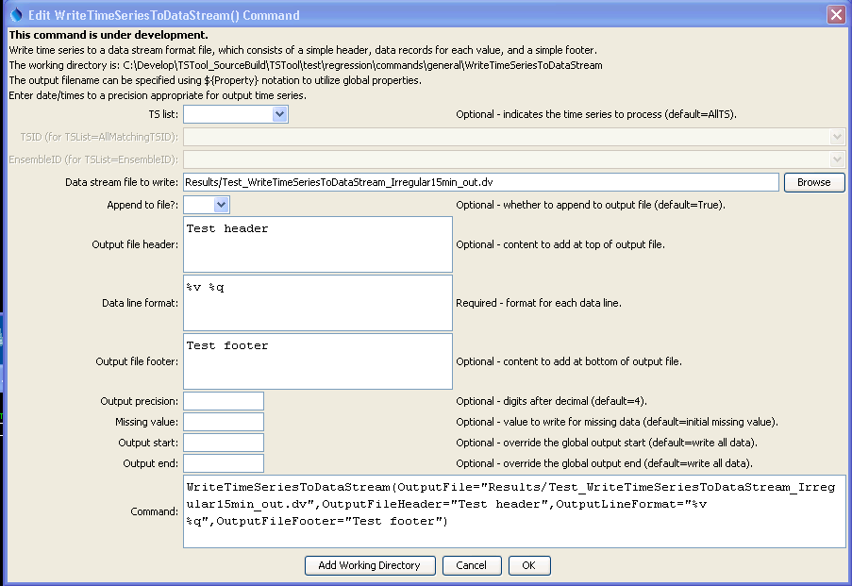
WriteTimeSeriesToDataStream
WriteTimeSeriesToDataStream() Command Editor

The command syntax is as follows:

WriteTimeSeriesToDataStream(Parameter=Value,…)

Command Parameters

Parameter | Description | Default
TSList | Indicates the list of time series to be processed, one of:  - AllMatchingTSID – all time series that match the TSID (single TSID or TSID with wildcards) will be processed.  - AllTS – all time series before the command.  - EnsembleID – all time series in the ensemble will be processed.  - FirstMatchingTSID – the first time series that matches the TSID (single TSID or TSID with wildcards) will be processed.  - LastMatchingTSID – the last time series that matches the TSID (single TSID or TSID with wildcards) will be processed.  - SelectedTS – the time series are those selected with the SelectTimeSeries() command. | AllTS
TSID | The time series identifier or alias for the time series to be processed, using the * wildcard character to match multiple time series. | Required if TSList=*TSID.
EnsembleID | The ensemble to be processed, if processing an ensemble. | Required if TSList= EnsembleID.
OutputFile | The output file. The path to the file can be absolute or relative to the working directory (command file location). Global properties can be used to specify the filename, using the ${Property} syntax. | None – must be specified.
Append | Indicate whether content should be appended to existing file. Need to figure out how to handle header and footer.
OutputFile  Header | Text that will be added to the top of the output file. | Do not include header content.
OutputLine  Format | Format that is used for each data value. Need to insert explanation of formats including ${ts:property} for time series properties and %v formats similar to graph data point label formatters. | Date and value.
OutputFile  Footer | Text that will be added to the bottom of the output file. | Do not include footer content.
Precision | The number of digits after the decimal for numerical output. | 4 (in the future may default based on data type)
MissingValue | The value to write to the file to indicate a missing value in the time series. | As initialized when reading the time series or creating a new time series, typically -999, NaN, or another value that is not expected in data.
OutputStart | The date/time for the start of the output. | Use the global output period.
OutputEnd | The date/time for the end of the output. | Use the global output period.

