Command Reference: RemoveFile()
Remove a file
Version 08.15.00, 2008-05-11

The RemoveFile() command removes a file from the file system. This command is used in testing software to remove results files before attempting to regenerate the results.

The following dialog is used to edit the command and illustrates the syntax for the command.

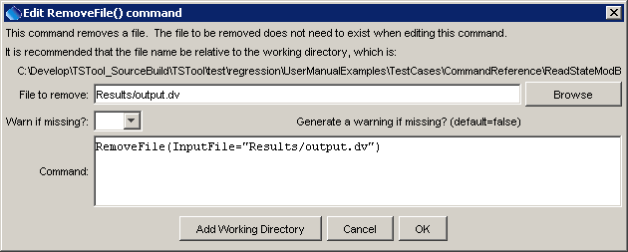
RemoveFile
RemoveFile() Command Editor

The command syntax is as follows:

RemoveFile(Parameter=Value,…)

Command Parameters

Parameter | Description | Default
InputFile | The name of the file to delete. | None – must be specified.

The following example command file illustrates how to remove a file:

RemoveFile(InputFile="Results/output.dv")

