Command Reference: SetPropertyFromNwsrfsAppDefault()
Set a property for the time series processor, using an NWSRFS App Default variable
Version 08.15.00, 2008-05-11

This is an experimental command that is being evaluated for advanced processing.

The SetPropertyFromNwsrfsAppDefault() command sets the value of a property used by the time series processor, using an National Weather Service River Forecast System (NWSRFS) App Default property value. These properties will ultimately be accessible by any command using ${Property} notation, for example to specify filenames more dynamically. At this time, only a few commands utilize the properties. This command should not be confused with the SetTimeSeriesProperty() command, which operates on specific time series.

The following dialog is used to edit this command and illustrates the syntax of the command.

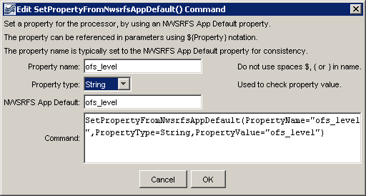
SetPropertyFromNwsrfsAppDefault
SetPropertyFromNwsrfsAppDefault() Command Editor

The command syntax is as follows:

SetPropertyFromNwsrfsAppDefault(Parameter=Value,…)

Command Parameters

Parameter | Description | Default
PropertyName | The property name. | None – must be specified.
PropertyType | The property type, used for validation, one of:  - DateTime – a date/time.  - Double – a floating point number  - Integer – an integer  - String – a string | None – must be specified.
PropertyValue | The NWSRFS App Default token name used to look up the property value. | None – must be specified.

A sample command file is as follows:

SetPropertyFromNwsrfsAppDefault(PropertyName="ofs_level",PropertyType=String,
PropertyValue="ofs_level")

