Command Reference: StartRegressionTestResultsReport()
Start a report file to contain regression test results
Version 08.15.00, 2008-05-11

The StartRegressionTestResultsReport() command starts a report file to be written to as regression tests are run. The CreateRegressionTestCommandFile() automatically inserts this command. The CompareFiles() and CompareTimeSeries() commands will write to this file if it is available.

The following dialog is used to edit the command and illustrates the syntax for the command.

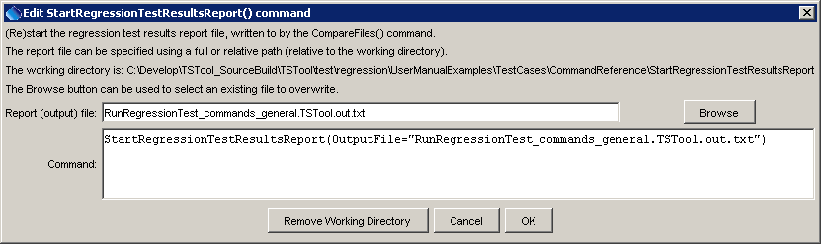
StartRegressionTestResultsReport
StartRegressionTestResultsReport() Command Editor

The command syntax is as follows:

StartRegressionTestResultsReport(Parameter=Value,…)

Command Parameters

Parameter | Description | Default
OutputFile | The name of the report file, enclosed in double quotes if the file contains spaces or other special characters. A path relative to the command file can be specified. | None – must be specified.

See the RunCommands() documentation for how to set up a regression test. The following command file illustrates how to start the results report:

StartRegressionTestResultsReport(
OutputFile="RunRegressionTest_commands_general.TSTool.out.txt")
…
RunCommands(InputFile="..\..\..\commands\general\ReadStateMod\Test_ReadStateMod_1.TSTool")
…

Each of the above command files should produce expected time series results, without warnings. If any command file unexpectedly produces a warning, a warning will also be visible in TSTool. The issue can then be evaluated to determine whether a software or configuration change is necessary. An example of the output file is:

SUCCESS C:\Develop\TSTool_SourceBuild\TSTool\test\regression\commands\general\add\Test_Add_1.TSTool
SUCCESS C:\Develop\TSTool_SourceBuild\TSTool\test\regression\commands\general\addConstant\Test_AddConstant_1.TSTool
SUCCESS C:\Develop\TSTool_SourceBuild\TSTool\test\regression\commands\general\adjustExtremes\Test_AdjustExtremes_1.TSTool
SUCCESS C:\Develop\TSTool_SourceBuild\TSTool\test\regression\commands\general\analyzePattern\Test_AnalyzePattern_FromMonthDataValues.TSTool
SUCCESS C:\Develop\TSTool_SourceBuild\TSTool\test\regression\commands\general\ARMA\Test_ARMA_1.TSTool
SUCCESS C:\Develop\TSTool_SourceBuild\TSTool\test\regression\commands\general\blend\Test_Blend_1.TSTool
SUCCESS C:\Develop\TSTool_SourceBuild\TSTool\test\regression\commands\general\ChangeInterval\Test_ChangeInterval_DayMean_To_MonthMean.TSTool
SUCCESS C:\Develop\TSTool_SourceBuild\TSTool\test\regression\commands\general\ChangePeriod\Test_ChangePeriod_1.TSTool
SUCCESS C:\Develop\TSTool_SourceBuild\TSTool\test\regression\commands\general\compareTimeSeries\Test_AllDifferent.TSTool
SUCCESS C:\Develop\TSTool_SourceBuild\TSTool\test\regression\commands\general\compareTimeSeries\Test_AllSame.TSTool
SUCCESS C:\Develop\TSTool_SourceBuild\TSTool\test\regression\commands\general\convertDataUnits\Test_ConvertDataUnits_1.TSTool
SUCCESS C:\Develop\TSTool_SourceBuild\TSTool\test\regression\commands\general\Copy\Test_Copy_1.TSTool
SUCCESS C:\Develop\TSTool_SourceBuild\TSTool\test\regression\commands\general\CreateEnsemble\Test_CreateEnsemble_1.TSTool
FAILURE C:\Develop\TSTool_SourceBuild\TSTool\test\regression\commands\general\CreateFromList\Test_CreateFromList_1.TSTool
WARNING C:\Develop\TSTool_SourceBuild\TSTool\test\regression\commands\general\CreateTraces_Alias\Test_CreateTraces_1.TSTool
SUCCESS C:\Develop\TSTool_SourceBuild\TSTool\test\regression\commands\general\cumulate\Test_Cumulate_1.TSTool
SUCCESS C:\Develop\TSTool_SourceBuild\TSTool\test\regression\commands\general\DeselectTimeSeries\Test_DeselectTimeSeries_1.TSTool
SUCCESS C:\Develop\TSTool_SourceBuild\TSTool\test\regression\commands\general\Disaggregate_Alias\Test_Disaggregate_1.TSTool
SUCCESS C:\Develop\TSTool_SourceBuild\TSTool\test\regression\commands\general\divide\Test_Divide_1.TSTool
WARNING C:\Develop\TSTool_SourceBuild\TSTool\test\regression\commands\general\fillCarryForward\Test_FillCarryForward_1.TSTool
SUCCESS C:\Develop\TSTool_SourceBuild\TSTool\test\regression\commands\general\fillConstant\Test_FillConstant_Day.TSTool

