Command Reference: WriteProperty()
Write a time series processor property to a file
Version 08.15.00, 2008-05-11

The WriteProperty() command writes the value of a time series processor property to a file. This is useful for testing that properties are being set. It could also be used to pass information from TSTool to another program. The format of the output is:

Property=”Value”

The following dialog is used to edit this command and illustrates the syntax of the command.

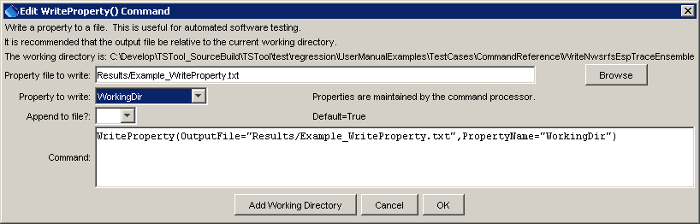
WriteProperty
WriteProperty() Command Editor

The command syntax is as follows:

WriteProperty(Parameter=Value,…)

Command Parameters

Parameter | Description | Default
OutputFile | The property file to write, as an absolute path or relative to the command file. | None – must be specified.
PropertyName | The property name to write | None – must be specified.
Append | Indicates whether the property should be appended to the file (True) or overwrite the file (False). | True

A sample command file is as follows:

WriteProperty(OutputFile="Results/Example_WriteProperty.txt",
PropertyName="WorkingDir")

