Command Reference: resequenceData()
Resequence time series data
Version 06.20.00, 2006-09-19, Color, Acrobat Distiller

The resequenceData() command resequences data in time series by shifting values from one period to another. For example, January 1950 might be shifted to January 1990. This command is useful for generating synthetic time series by resequencing historical data. The following constraints apply:

- Processing occurs by calendar year.
- Full start and end years are required.
- For a daily data interval:
  - If a short year (i.e., non-leap year with 365 days) is transferred to a long year (i.e., a leap year with 366 days), the first day after the short year is used for the 366th day during the transfer. What to do if the year being transferred is the last in the data set and no more years are available for the 366th day – repeat the last day?
  - If a long year (i.e., leap year with 366 days) is transferred to a short year (i.e., a non-leap year with 365 days), the 366th day in the leap year is not transferred.
- The original period is retained in the time series. For example, if the original data are 1937 to 1997, the resequenced data will also be in a time series with a period 1937 to 1997.

The following dialog is used to edit the command and illustrates the syntax of the command (THE FOLLOWING NEEDS TO BE REPLACED – IT IS AN EXAMPLE USING A DIFFERENT COMMAND).

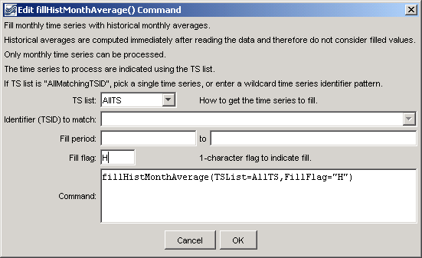
resequenceData
resequenceData() Command Editor (TO BE UPDATED – THE ABOVE IS A DIFFERENT COMMAND)

The command syntax is as follows:

resequenceData(param=value,…)

Command Parameters

Parameter | Description | Default
TSList | Indicate how to determine the list of time series to process, one of:  - AllMatchingTSID – process time series that have identifiers matching the TSID parameter.  - AllTS – process all the time series.  - SelectedTS – process the time series that are selected (see selectTimeSeries()). | None – must be specified.
TSID | Used if TSList=AllMatchingTSID to indicate the time series identifier or alias for the time series to be filled. Specify * to match all time series or use a wildcard for one or more identifier parts. | Required if TSList=AllMatchingTSID.
TableID | The identifier for the sequence table to use, which indicates the dates to use when resequencing data (e.g., list of years for data sequence). | None – must be specified.
SequenceInterval | The interval for blocks of data being resequenced, one of:  - Year – shift full years of data (requires use of the TableYearCol parameter).  - Month – shift full months of data (requires use of the TableYearCol and TableMonthCol parameters). This option is envisioned for the future but not enabled. | Year (only option that is currently enabled).
TableYearCol | Column in the sequence table indicating the sequence of years to use during processing – specify a column 1+ or a column name (if names are used in the table). | 1
Bracket | The number of data values to smooth on each side of the boundary between sequence blocks, to minimize discontinuities. For example, a value of 1 with monthly time series will smooth the last month of one year with the first month of the next year. See the AdjustMethod parameter. This parameter is envisioned for implementation if necessary but is not currently enabled. | 0 – no smoothing.
AdjustMethod | To be determined – not yet enabled. | Not yet enabled.

The following example:

- Reads a list of time series from a StateMod file.
- Reads a sequence of years from a delimited file.
- Resequences the StateMod time series data.
- Runs StateMod.
- Reads StateMod output time series from the StateMod binary file.
- Write a selected time series to a RiverWare file.

# Read all demand time series…
readStateMod(InputFile=”..\StateMod\gunnC2005.ddm”)
# Read the sequence of years to use…
Table 0001HK0101 = readTable(InputFile=”0001HK0101.csv”)
# Resequence the StateMod time series…
resequenceData(TSList=AllTS,TableID=”Traces”,SequenceInterval=Year,
TableYearCol=Trace1)
# Run StateMod
runProgram(CommandLine=”statemod …”)
# Read StateMod results…
readStateModB(InputFile=”..\StateMod\gunnC2005C.B43”)
# Write RiverWare time series (repeat for all desired locations)…
writeRiverWare(TSID=”SomeGage…Month”,OutputFile=”SomeGage_0001HK0101.rdf”)

The year sequence is specified in a file similar to the following.

Trace1,Trace2,…
1905,1967
1920,1943
etc.

This page is intentionally blank.

