Command Reference: SetConstant()
Set time series data to a single or monthly constant values
Version 08.15.00, 2008-05-11

The SetConstant() command sets the values of a time series to a single or monthly constant values.

The following dialog is used to edit the command and illustrates the command syntax:

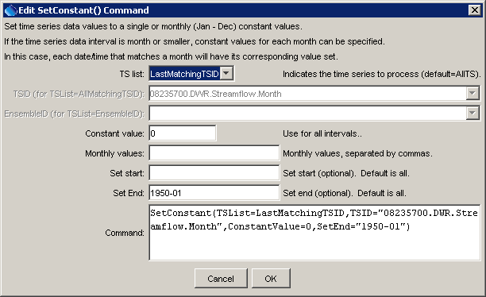
SetConstant
SetConstant() Command Editor

The command syntax is as follows:

SetConstant(Parameter=Value,…)

Command Parameters

Parameter | Description | Default
TSList | Indicates the list of time series to be processed, one of:  - AllMatchingTSID – all time series that match the TSID (single TSID or TSID with wildcards) will be modified.  - AllTS – all time series before the command.  - EnsembleID – all time series in the ensemble will be modified.  - LastMatchingTSID – the last time series that matches the TSID (single TSID or TSID with wildcards) will be modified.  - SelectedTS – the time series are those selected with the SelectTimeSeries() command. | AllTS
TSID | The time series identifier or alias for the time series to be modified, using the * wildcard character to match multiple time series. | TSID or EnsembleID must be specified if identifiers are being matched.
EnsembleID | The ensemble to be modified, if processing an ensemble. | TSID or EnsembleID must be specified if identifiers are being matched.
ConstantValue | The constant value to use as the data value. | None – must be specified, or specify monthly values.
MonthValues | Monthly values to use as the data values. Twelve values can be specified, separated by commas. If the time series data interval is less than monthly, each date/time will be set for a specific month. | None – must be specified, or specify a constant value.
SetStart | The starting date/time for the data set. | Set data for the full period.
SetEnd | The ending date/time for the data set. | Set data for the full period.

A sample command file to process a time series from the State of Colorado’s HydroBase is as follows (only the early period is set to zero):

# 08235700 - ALAMOSA RIVER BELOW CASTLEMAN GULCH NEAR JASPER
08235700.DWR.Streamflow.Month~HydroBase
SetConstant(TSList=AllMatchingTSID,TSID="08235700.DWR.Streamflow.Month",
ConstantValue=0,SetEnd="1950-01")

