Command Reference: WriteDateValue()
Write time series to a DateValue format file
Version 08.15.00, 2008-05-12

The WriteDateValue() command will write time series in memory to the specified DateValue format file. See the DateValue Input Type Appendix for more information about the file format. The time series should have the same data interval.

The following dialog is used to edit the command and illustrates the syntax of the command.

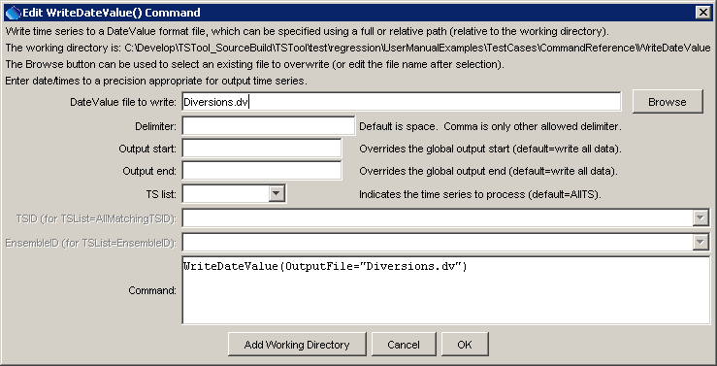
WriteDateValue
WriteDateValue() Command Editor

The command syntax is as follows:

WriteDateValue(Parameter=Value,…)

Command Parameters

Parameter | Description | Default
OutputFile | The DateValue output file. The path to the file can be absolute or relative to the working directory (command file location). | None – must be specified.
Delimiter | The delimiter character to use between data values. Comma is the only other allowed value other than the default space. | Space.
OutputStart | The date/time for the start of the output. | Use the global output period.
OutputEnd | The date/time for the end of the output. | Use the global output period.
TSList | Indicates the list of time series to be processed, one of:  - AllMatchingTSID – all time series that match the TSID (single TSID or TSID with wildcards) will be modified.  - AllTS – all time series before the command.  - EnsembleID – all time series in the ensemble will be modified.  - LastMatchingTSID – the last time series that matches the TSID (single TSID or TSID with wildcards) will be modified.  - SelectedTS – the time series are those selected with the SelectTimeSeries() command. | AllTS
TSID | The time series identifier or alias for the time series to be modified, using the * wildcard character to match multiple time series. | TSID or EnsembleID must be specified.
EnsembleID | The ensemble to be modified, if processing an ensemble. | TSID or EnsembleID must be specified.

A sample commands file is as follows:

# 0100501 - EMPIRE DITCH
0100501.DWR.DivTotal.Month~HydroBase
# 0100503 - RIVERSIDE CANAL
0100503.DWR.DivTotal.Month~HydroBase
WriteDateValue(OutputFile="Diversions.dv")

