Command Reference: WriteNwsrfsEspTraceEnsemble()
Write a time series ensemble to an NWSRFS ESP trace ensemble format file
Version 08.15.00, 2008-05-12

The WriteNwsrfsEspTraceEnsemble() command writes time series traces to the specified National Weather Service River Forecast System (NWSRFS) ESP trace ensemble file. See the NWSRFS ESP Trace Ensemble Input Type Appendix for more information about the file format. The time series should have the same header information, with the sequence number indicating the trace years. For example use time series that are managed as an ensemble in TSTool.

The following dialog is used to edit the command and illustrates the syntax of the command.

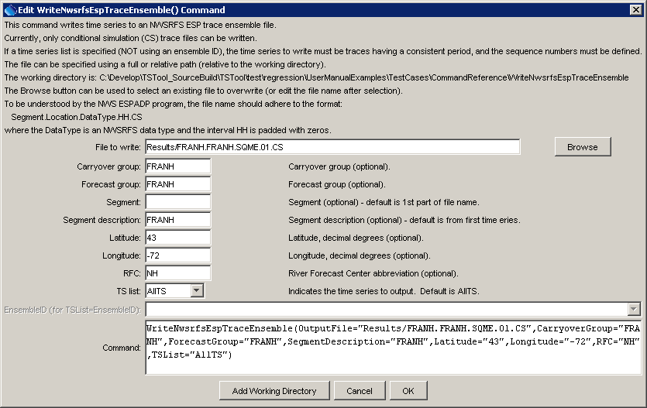
WriteNwsrfsEspTraceEnsemble
WriteNwsrfsEspTraceEnsemble() Command Editor

The command syntax is as follows:

WriteNwsrfsEspTraceEnsemble(Parameter=Value,…)

Command Parameters

Parameter | Description | Default
OutputFile | The NWSRFS ESP trace ensemble output file. The path to the file can be absolute or relative to the working directory. The Browse button can be used to select the file to write (if a relative path is desired, delete the leading path after the select). | None – must be specified.
CarryoverGroup | The carryover group to use in the trace file header information | Blank.
ForecastGroup | The forecast group to use in the trace file header information. | Blank.
Segment | The segment identifier to use in the trace file header information. | Location part of the time series identifier, from the first time series.
SegmentDescription | The segment description to use in the trace file header information. | Blank.
Latitude | The latitude for the station to use in the trace file header information, decimal degrees. | Missing.
Longitude | The longitude for the station to use in the trace file header information, decimal degrees. | Missing.
RFC | The river forecast center to use in the trace file header information. | Blank.
TSList | Indicates the time series to be output, one of:  - AllTS – all available time series will be output.  - SelectedTS – time series that have been selected with the SelectTimeSeries() command will be output.  - EnsembleID – time series in the ensemble specified by Blank. | AllTS
EnsembleID | The ensemble to write, if TSList=EnsembleID. | Required if TSList=EnsembleID.

A sample commands file to convert an ensemble from a DateValue file to NWS ESP format is as follows:

ReadDateValue(InputFile="Data/FRANH.ESP.SQME.1HOUR.QPF1.TRACE2001")
WriteNwsrfsEspTraceEnsemble(OutputFile="Results/FRANH.FRANH.SQME.01.CS",
CarryoverGroup="FRANH",ForecastGroup="FRANH",SegmentDescription="FRANH",
Latitude="43",Longitude="-72",RFC="NH",TSList="AllTS")

