Command Reference: TimeSeriesToTable()
Copy one or more time series into a table
Version 10.22.00, 2013-08-18

The TimeSeriesToTable() command copies one or more time series into a table. This command is useful when performing table analysis processing and outputting table formats (e.g., with the WriteTableToDelimitedFile() or WriteTableToHTML() commands). The command can be configured to output one of two table forms:

- Each time series in a separate column, with shared date/time column:
  - The time series must be regular interval (no irregular interval time series) and the intervals must match in order to allow alignment of the date/times.
  - Do not specify the TableTSIDColumn or TableTSIDFormat parameters.
- All time series values in a single column (useful for converting time series to a stream of data for loading into a database)
  - Any interval is allowed although mixing time series of varying precision is discouraged.
  - Specify the TableTSIDColumn and optionally TableTSIDFormat parameters.

Currently the command can only be used to create a new table but in the future the command is envisioned to write into an existing table. The following dialog is used to edit the command and illustrates the syntax of the command when writing a multi-column data table while also outputting data flags. Note that the value columns can be specified using time series properties.

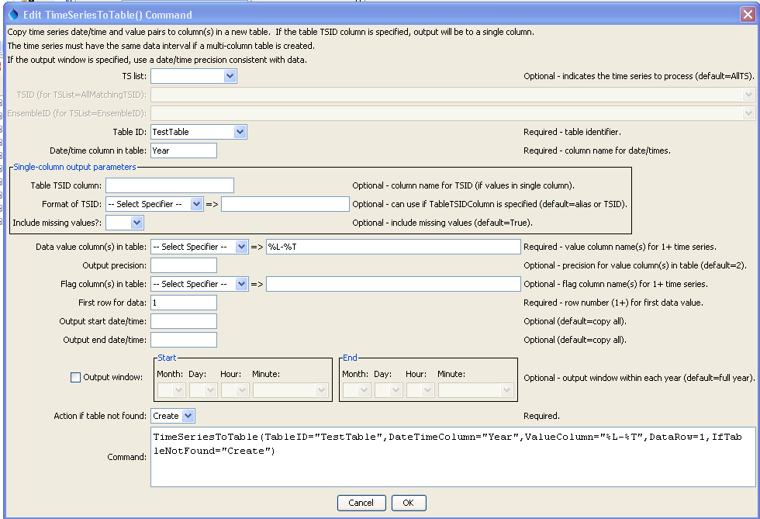
TimeSeriesToTable (TimeSeriesToTable_Year_Create)
TimeSeriesToTable() Command Editor to Create Multi-Column Data Table

The command syntax is as follows:

TimeSeriesToTable(Parameter=Value,…)

Command Parameters

Parameter | Description | Default
TSList | Indicates the list of time series to be processed, one of:  - AllMatchingTSID – all time series that match the TSID (single TSID or TSID with wildcards).  - AllTS – all time series before the command.  - EnsembleID – all time series in the ensemble.  - FirstMatchingTSID – the first time series that matches the TSID (single TSID or TSID with wildcards).  - LastMatchingTSID – the last time series that matches the TSID (single TSID or TSID with wildcards).  - SelectedTS – the time series are those selected with the SelectTimeSeries() command. | AllTS
TSID | The time series identifier or alias for the time series to be modified, using the * wildcard character to match multiple time series. | Required when TSList=*TSID
EnsembleID | The ensemble to be modified, if processing an ensemble. | Required when TSList=EnsembleID.
TableID | The identifier for the table to copy data into (or the identifier for the new table to create if IfTableNotFound=Create). | None – must be specified.
DateTimeColumn | The table column name to receive date/time information. | None – must be specified.
TableTSIDColumn | For single-column output, the name of the column in the table for time series identifier information. The format of the identifier can be specified using the TableTSIDFormat parameter. | Optional – if specified will indicate single-column output.
TableTSIDFormat | For single-column output, indicates how to format the time series identifier that is inserted in the column specified by the TableTSIDColumn parameter. | Optional – if not specified the alias or full TSID will be used.
Include  MissingValues | For single-column output, indicates whether missing values should be transferred to the table. This is useful to screen out missing values from sparse time series. | True
ValueColumn | The data value column name(s) to receive time series data, specified as follows:  - Multiple names separated by a comma.  - Time series property format specifiers, available in a list of choices. These specifiers are consistent with other commands and the legend formatter in the graphing tool.  - If a literal string is specified with multi-column output, names for columns 2+ will be generated by adding a sequential number to ValueColumn. | None – must be specified.
OutputPrecision | The number of digits after the decimal to use for data values in the output table. | 2 (in the future may auto-detect from units)
FlagColumn | The data flag column name(s) to receive time series flags, specified using the same syntax as ValueColumn. A blank in the list will result in no transfer of flags for the specific time series. | Do not output flags to the table.
DataRow1 | First table row for data (1+), where the row number is data only (column names are not considered a data row). | None – must be specified.
OutputStart | The starting date/time for the copy. | Available period.
OutputEnd | The ending date/time for the copy. | Available period.
OutputWindowStart | The calendar date/time for the output start within each year. Specify using the format MM, MM-DD, MM-DD hh, or MM-DD hh:mm, consistent with the time series interval precision. A year of 2000 will be used internally to parse the date/time. Use this parameter to limit data processing within the year, for example to output only a single month or a season. | Output the full year.
OutputWindowEnd | Specify date/time for the output end within each year. See OutputWindowStart for details. | Output the full year.
IfTableNotFound | Indicate action if the table identifier is not matched, one of:  - Create – create a new table  - Warn – warn that the table was not matched | Warn

A sample command file is as follows (this command file is used to verify the command during testing):

# Test copying annual time series to a table, and also create the table
StartLog(LogFile="Results/Test_TimeSeriesToTable_Year_Create.TSTool.log")
RemoveFile(InputFile="Results/Test_TimeSeriesToTable_Year_Create_out.csv",
IfNotFound=Ignore)
NewPatternTimeSeries(Alias=”ts1”,NewTSID="ts1..Flow.Year",SetStart="1960",
SetEnd="2000",Units="ACFT",PatternValues="1,2,5,8,,20")
NewPatternTimeSeries(Alias=”ts2”,NewTSID="ts2..Flow.Year",SetStart="1950",
SetEnd="2005",Units="ACFT",PatternValues="2,4,10,16,,40")
TimeSeriesToTable(TableID=TestTable,DateTimeColumn=Year,ValueColumn=%L-%T,
FlagColumn=”%L-%T-flag”,DataRow=1,IfTableNotFound="Create")
# Generate the results.
WriteTableToDelimitedFile(TableID="TestTable",
OutputFile="Results\Test_TimeSeriesToTable_Year_Create_out.csv")
# Uncomment the following to recreate expected results
# WriteTableToDelimitedFile(TableID="TestTable",
# OutputFile="ExpectedResults\Test_TimeSeriesToTable_Year_Create_out.csv")
CompareFiles(InputFile1="ExpectedResults/Test_TimeSeriesToTable_Year_Create_out.csv",
InputFile2="Results/Test_TimeSeriesToTable_Year_Create_out.csv",IfDifferent=Warn)

The resulting table will be listed in the Tables area of the TSTool interface and clicking on the TestTable identifier will display the table similar to the following:

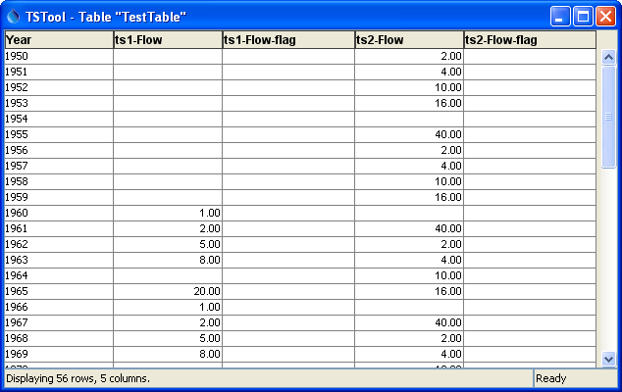
TimeSeriesToTable2
Multi-Column Data Table

The following example illustrates how to create a single data column table. Because a single column is being used for data, the data value and corresponding data flag column names are specified literally (not as time series properties). The column and format for the TSID also must be specified.

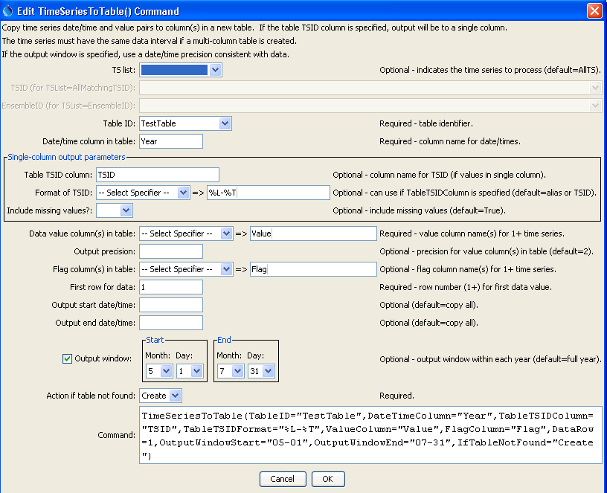
TimeSeriesToTable_Single (Day_MayJul_Single_Flag)
TimeSeriesToTable() Command Editor to Create Single Data Column Table

The resulting table is as shown in the following figure:

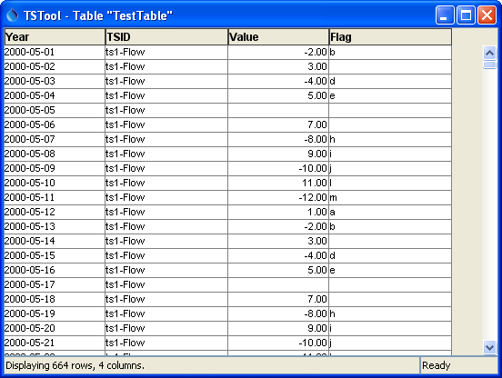
TimeSeriesToTable_Single2
Single Data Column Table

