Command Reference: ReadHydroBase()
Read time series from a HydroBase database
Version 10.00.00, 2011-03-28

The ReadHydroBase() command reads one or more time series from the HydroBase database (see the HydroBase Input Type Appendix). It is designed to utilize query criteria to process large numbers of time series.

The following special actions occur, depending on data type:

- Daily diversion (DivTotal and DivClass) and reservoir release (RelTotal and RelClass) time series have their values automatically carried forward to fill data within irrigation years (Nov to Oct). HydroBase only stores full months of data when non-zero observations or non-zero filled values occur in a month. Therefore, this filling action should only provide additional zero values. Irrigation years with no observations remain as missing after the read. See the FillHistMonthAverage() command, which often is used to fill completely missing years.
- Daily, monthly, and yearly diversion and reservoir release time series optionally can be filled using diversion comments, which indicate when irritation years should be treated as missing. See the FillUsingDivComments parameter below. Note that diversion comments should not conflict with more detailed records but and provide additional information. The older FillUsingDivComments() command also is available for filling.

The following dialog is used to edit the command and illustrates the syntax for the command. Two options are available for matching time series, based on historical software requirements. The following example illustrates how to read a single time series.

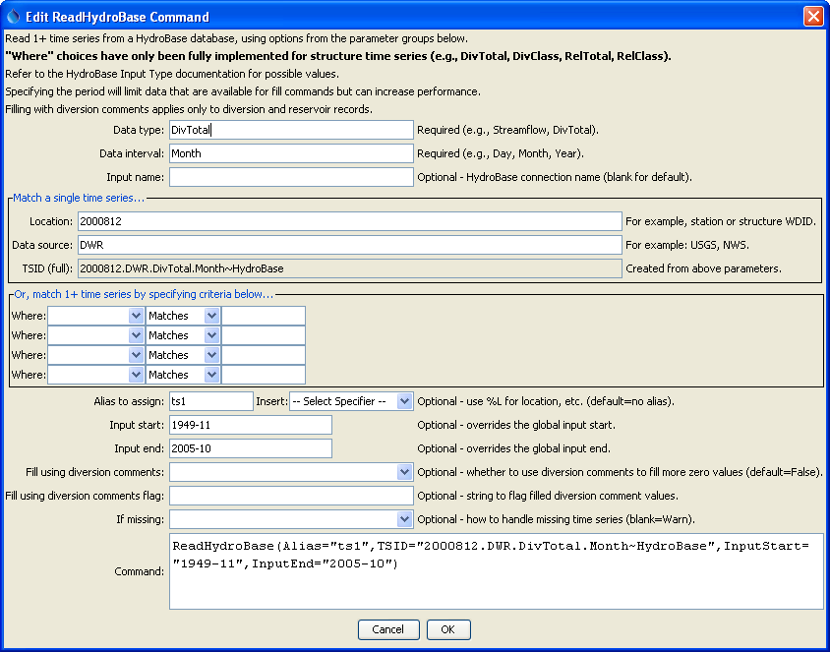
ReadHydroBase_TSID
ReadHydroBase() Command Editor to Read a Single Time Series

The Data type, Data interval, and Where input fields are similar to those from the main TSTool interface. However, whereas the interactive interface first requires a query to find the matching time series list and then an interactive select for specific time series identifiers, the ReadHydroBase() command reads the time series list and the corresponding data for the time series. This can greatly shorten command files and simplify command logic, especially when processing large amounts of data.

Currently the Data type and Data interval must be entered manually (drop-down choices are not available), according to the HydroBase Input Type Appendix. Only the structure data types (in particular diversions) are supported in when using the Where filters. Support for other data types will be added as resources allow.
The following figure illustrates how to query multiple time series.

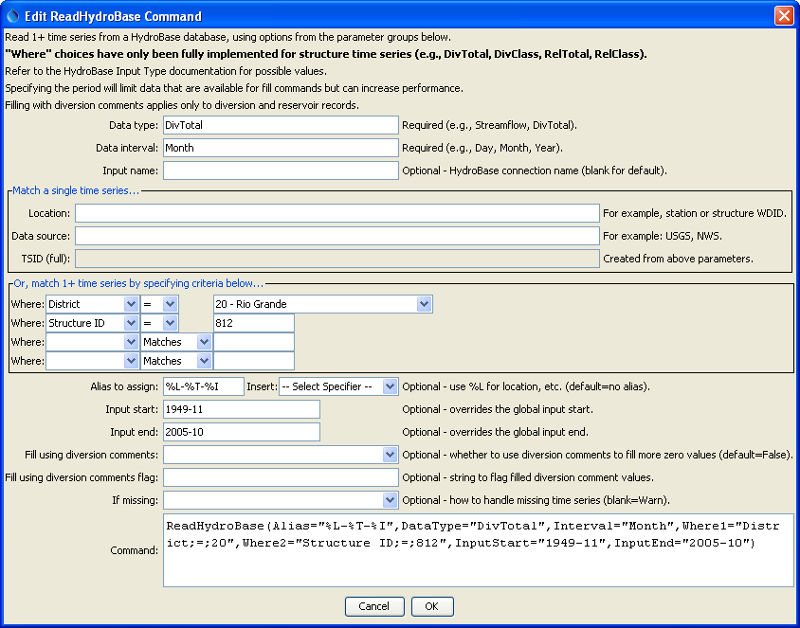
ReadHydroBase
ReadHydroBase() Command Editor to Read Multiple Time Series

The command syntax is as follows:

ReadHydroBase(Parameter=Value,…)

The following older command syntax is updated to the above syntax when a command file is read:

TS Alias = ReadHydroBase(Parameter=Value,…)

Command Parameters

Parameter | Description | Default
DataType | The data type to be queried, as documented in the HydroBase Input Type Appendix. The following conditions apply:  - For diversions, use DivClass without the SFUT sub-type. The SFUT sub-type will be added after data are queried.  - For reservoir releases, use RelClass without the SFUT sub-type. The SFUT sub-type will be added after data are queried. | None – must be specified.
Interval | The data interval for the time series, as documented in the HydroBase Input Type Appendix (e.g. Day, Month, Year). | None – must be specified.
InputName | The HydroBase database connection input name to use for the connection, as initialized in OpenHydroBase(), which allows reading from more than one HydroBase in the same commands file. | Use the default HydroBase connection.
TSID | A time series identifier to read when matching a single time series – see the HydroBase Input Type Appendix. If specified, this parameter will override the WhereN parameters. | Use WhereN parameters.
WhereN | The “where” clauses to be applied when querying data, matching the values in the Where fields in the command editor dialog and the TSTool main interface. The parameters should be named Where1, Where2, etc., with a gap resulting in the remaining items being ignored. The format of each value is:  “Item;Operator;Value”  Where Item indicates a data field to be filtered on, Operator is the type of constraint, and Value is the value to be checked when querying. | If not specified, the query will not be limited and very large numbers of time series may be queried.
Alias | The alias to assign to the time series, as a literal string or using the special formatting characters listed by the command editor. The alias is a short identifier used by other commands to locate time series for processing, as an alternative to the time series identifier (TSID). | None – must be specified.
InputStart | Start of the period to query, specified as a date/time with a precision that matches the requested data interval. | Read all available data.
InputEnd | End of the period to query, specified as a date/time with a precision that matches the requested data interval. | Read all available data.
FillUsing  DivComments | Indicate whether to fill diversion and reservoir release time series using diversion comments. | False
FillUsing  DivComments  Flag | If specified as a single character, data flags will be enabled for the time series and each filled value will be tagged with the specified character. The flag can then be used later to label graphs, etc. The flag will be appended to existing flags if necessary. | No flag is assigned.
IfMissing | Indicate the action to be taken if the requested time series is missing, one of:  - Ignore – ignore the time series (do not warn and the time series will not be available)  - Warn – generate a failure for the command | Warn

A sample command file is as follows (read all reservoir releases to structure 0300905):

ReadHydroBase(DataType="DivClass",Interval="Day",
Where1="District;Equals;3",
Where2="Structure ID;Equals;905",Where3="SFUT;Contains;s:2")

