Command Reference: WriteTimeSeriesProperty()
Write a time series property to a file
Version 08.16.03, 2008-08-18

This command is under development and is used primarily for software testing. In particular one limitation is that the time series identifier is not included in output and therefore properties for multiple time series are not uniquely identified.

The WriteTimeSeriesProperty() command writes the value of a time series property to a file. This command should not be confused with the WriteProperty() command, which writes processor properties. This is useful for testing whether properties are being set. It could also be used to pass information from TSTool to another program. The format of the output is:

Property=”Value”

Multi-line properties will be contained within the quotes. The number of properties is limited at this time, as needed for testing software, but may be increased in the future. The format of output may also change in the future.

The following dialog is used to edit this command and illustrates the syntax of the command.

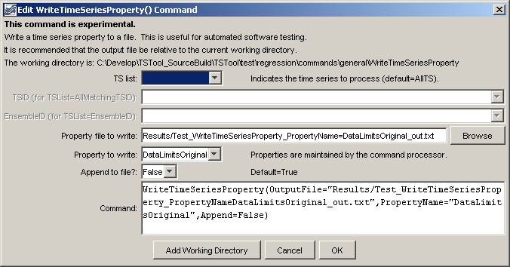
WriteTimeSeriesProperty
WriteTimeSeriesProperty() Command Editor

The command syntax is as follows:

WriteTimeSeriesProperty(Parameter=Value,…)

Command Parameters

Parameter | Description | Default
TSList | Indicates the list of time series to be processed, one of:  - AllMatchingTSID – all time series that match the TSID (single TSID or TSID with wildcards) will be modified.  - AllTS – all time series before the command.  - EnsembleID – all time series in the ensemble will be modified.  - FirstMatchingTSID – the first time series that matches the TSID (single TSID or TSID with wildcards) will be modified.  - LastMatchingTSID – the last time series that matches the TSID (single TSID or TSID with wildcards) will be modified.  - SelectedTS – the time series are those selected with the SelectTimeSeries() command. | AllTS
TSID | The time series identifier or alias for the time series to be modified, using the * wildcard character to match multiple time series. | Required when TSList=*TSID
EnsembleID | The ensemble to be modified, if processing an ensemble. | Required when TSList=EnsembleID.
OutputFile | The property file to write, as an absolute path or relative to the command file. | None – must be specified.
PropertyName | The property name to write. | None – must be specified.
Append | Indicates whether the property should be appended to the file (True) or overwrite the file (False). | True

A sample command file is as follows:

WriteTimeSeriesProperty(OutputFile="Results/Example_WriteTimeSeriesProperty.txt",
PropertyName="DataLimitsOriginal")

