Command Reference: ReadPropertiesFromFile()
Read one or more time series processor properties from a file
Version 10.12.00, 2012-08-02

The ReadPropertiesToFile() command reads the values of one or more time series processor properties from a file. The corresponding WritePropertiesToFile() command can be used to write properties to a file. Processor properties include global defaults such as InputStart, InputEnd, OutputStart, OutputEnd, OutputYearType, WorkingDir, and also user-defined properties set with the SetProperty() command. Internally, properties have a name and a value, which is of a certain type (string, integer, date/time, etc.). Examples of using the command include:

- creating tests to verify that properties are being set
- passing information from another program, such as a Python script, to TSTool
- reading persistent information from a previous use, such as the date/time that data were last downloaded from a web service

A number of property formats are supported as listed in the following table.

Property File Formats

Format | Description
NameValue | Simple format, all properties handled as text:  PropertyName=PropertyValue  PropertyName=”Property value, quoted if necessary”
NameTypeValue | Same as NameValue format, with non-primitive objects treated as simple constructors:  PropertyName=PropertyValue  DateTimeProperty=DateTime(“2010-10-01 12:30”)
NameTypeValue  Python | Similar to the NameTypeValue format, however, objects are represented using “Pythonic” notation, to allow the file to be used directly by Python scripts:  PropertyName=”PropertyValue”  DateTimeProperty=DateTime(2010,10,1,12,30)

The format of the file currently is not required when reading the file because the command detects the format for each property and creates an appropriate object type. If this becomes an issue, the command may be enhanced to add a parameter to specify the format (similar to the WritePropertiesToFile() command).
The following dialog is used to edit this command and illustrates the syntax of the command.

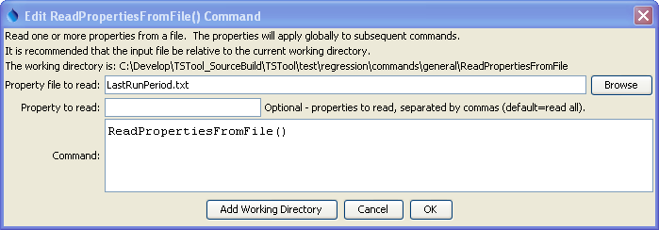
ReadPropertiesFromFile
ReadPropertiesFromFile() Command Editor

The command syntax is as follows:

ReadPropertiesFromFile(Parameter=Value,…)

Command Parameters

Parameter | Description | Default
InputFile | The property file to read, as an absolute path or relative to the command file. | None – must be specified.
IncludeProperty | The names of properties to read, separated by commas. | If not specified, all processor properties will be written.

