Command Reference: WritePropertiesToFile()
Write one or more time series processor properties to a file
Version 10.12.00, 2012-07-27

The WritePropertiesToFile() command writes the value of one or more time series processor properties to a file (this command replaces the older WriteProperty() command, which is being phased out). The ReadPropertiesFromFile() command can be used to read properties from a file. Processor properties include global defaults such as InputStart, InputEnd, OutputStart, OutputEnd, OutputYearType, WorkingDir, and also user-defined properties set with the SetProperty() command. Internally, properties have a name and a value, which is of a certain type (string, integer, date/time, etc.). Examples of using the command include:

- creating tests to verify that properties are being set
- passing information from TSTool to another program, such as a Python script
- storing persistent information for later use, such as the date/time that data were last downloaded from a web service

A number of property formats are supported as listed in the following table.

Property File Formats

Format | Description
NameValue | Simple format, all properties handled as text:  PropertyName=PropertyValue  PropertyName=”Property value, quoted if necessary”
NameTypeValue | Same as NameValue format, with non-primitive objects treated as simple constructors:  PropertyName=PropertyValue  DateTimeProperty=DateTime(“2010-10-01 12:30”)
NameTypeValue  Python | Similar to the NameTypeValue format, however, objects are represented using “Pythonic” notation, to allow the file to be used directly by Python scripts:  PropertyName=”PropertyValue”  DateTimeProperty=DateTime(2010,10,1,12,30)

The following dialog is used to edit this command and illustrates the syntax of the command.

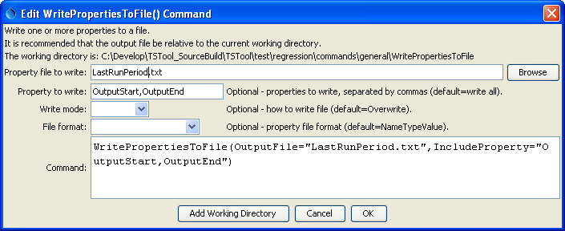
WritePropertiesToFile
WritePropertiesToFile() Command Editor

The command syntax is as follows:

WritePropertiesToFile(Parameter=Value,…)

Command Parameters

Parameter | Description | Default
OutputFile | The property file to write, as an absolute path or relative to the command file. | None – must be specified.
IncludeProperty | The names of properties to write, separated by commas. | If not specified, all processor properties will be written.
WriteMode | Indicates how the file should be written:  - Append – append the properties to the file without checking for matches (create the file if it does not exist)  - Overwrite – overwrite the properties file  - Update – update the properties in the file by first checking for matching property names (which will be updated) and then appending unmatched properties (not yet implemented) | Overwrite
FileFormat | Format of the properties file (see descriptions in the above Property File Formats table):  - NameValue  - NameTypeValue  - NameTypeValuePython | NameValue

