Command Reference: SetDataValue()
Set a data value at a single date/time
Version 08.16.04, 2008-09-12

The SetDataValue() command sets a single data value in a time series. Consequently, it can be used to condition a value for subsequent filling (e.g., with FillRepeat()) or to "hard-code" data that may not be available in files or databases. It is good practice to insert comments when editing data to explain the edits. See also the SetConstant() command.

The following dialog is used to edit the command and illustrates the syntax of the command.

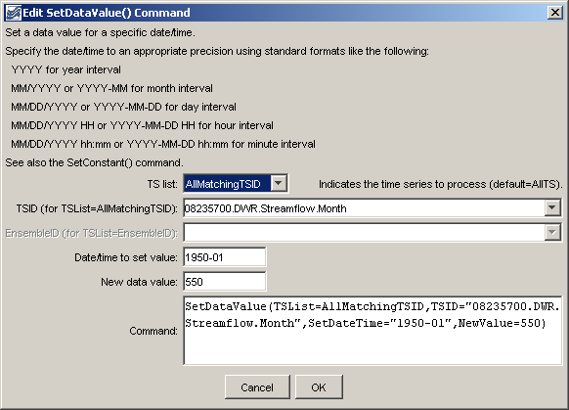
SetDataValue
SetDataValue() Command Editor

The command syntax is as follows:

SetDataValue(Parameter=Value,…)

Command Parameters

Parameter | Description | Default
TSID | The time series identifier or alias for the time series to be modified. | None – must be specified.
SetDateTime | The date/time at which the data value should be set. Specify the date/time precision according to the time series that is being manipulated. | None – must be specified.
NewValue | The new data value. | None – must be specified.

A sample command file to process data from the State of Colorado’s HydroBase database is as follows:

# 08235700 - ALAMOSA RIVER BELOW CASTLEMAN GULCH NEAR JASPER
08235700.DWR.Streamflow.Month~HydroBase
SetDataValue(TSList=AllMatchingTSID,TSID=”08235700.DWR.Streamflow.Month”,
SetDateTime=”1950-01”,NewValue=550)

