Command Reference: SortTable()
Sort a table’s rows by sorting values in a column
Version 10.23.00, 2013-09-16

The SortTable() command sorts rows in a table by sorting the values in a column..

The following dialog is used to edit the command and illustrates the syntax of the command

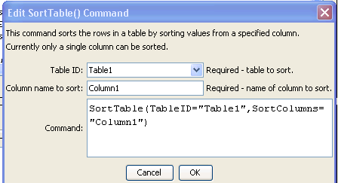
SortTable
SortTable() Command Editor

The command syntax is as follows:

SortTable(Parameter=Value,…)

Command Parameters

Parameter | Description | Default
TableID | The identifier for the table. | None – must be specified.
SortColumns | The names of columns to sort, separated by commas. Currently only a single column can be specified. | None – must be specified.

