Command Reference: WriteTableToHTML()
Write a table to an HTML file
Version 09.10.01, 2010-12-07

The WriteTableToHTML() command writes a table to an HTML file. It can be used to publish tables to the web.

Table column names are output as the HTML table column headers. Formatting for cell values is based on the precision of the original table data. Default styles are written at the top of the HTML. In the future the command may accept styles as input.

The following dialog is used to edit the command and illustrates the syntax for the command.

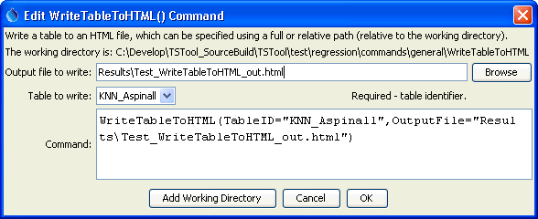
WriteTableToHTML
WriteTableToHTML() Command Editor

The command syntax is as follows:

WriteTableToHTML(Parameter=Value,…)

Command Parameters

Parameter | Description | Default
TableID | Identifier for the table to write. | None – must be specified.
OutputFile | The name of the file to write, as an absolute path or relative to the command file location. | None – must be specified.

