Command Reference: SortTimeSeries()
Sort time series by their identifiers
Version 10.31.00, 2013-07-21

The SortTimeSeries() command sorts the time series based on the specified criteria:

- the time series identifier or alias
- a time series property
- a string formatted from time series properties

This command is useful for ordering time series before writing output or visualization.

The following dialog is used to edit the command and illustrates the syntax for the command.

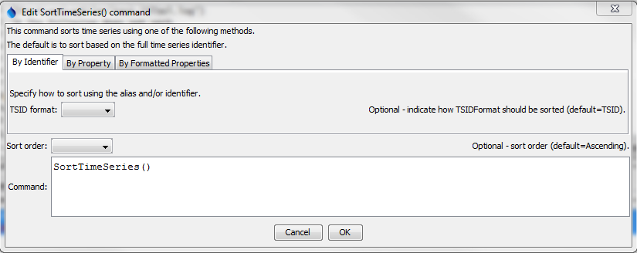
SortTimeSeries
SortTimeSeries() Command Editor Showing Parameter to Sort by TSID/Alias

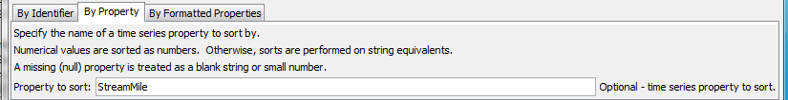
SortTimeSeries_Property
SortTimeSeries() Command Editor Showing Parameter to Sort by a Time Series Property

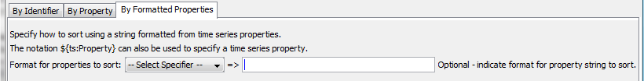
SortTimeSeries
SortTimeSeries() Command Editor Showing Parameter to Sort by Formatted Properties

The command syntax is as follows:

SortTimeSeries(Parameter=Value,…)

Command Parameters

Parameter | Description | Default
TSIDFormat | Sort by alias or TSID, determining the identifier for each time series as per the parameter value:  - AliasTSID – use the alias if available, and if not use the TSID  - TSID – Use the TSID only (regardless of whether the alias is available) | TSID
Property | Sort using the values of the specified time series property. Nulls are treated as blanks if strings and very small number for integers and floating point numbers.
PropertyFormat | Sort using a string that formats one or more time series properties, indicated with:  - %-specifiers (e.g., %L for location ID)  - ${ts:property} notation
SortOrder | Sort order, either Ascending or Descending. | Ascending

A sample command file using data from the State of Colorado’s HydroBase is as follows:

06756500.USGS.Streamflow.Month~HydroBase
# 06758300 - KIOWA CREEK AT BENNETT, CO.
06758300.USGS.Streamflow.Month~HydroBase
# 06758000 - KIOWA CREEK AT ELBERT, CO.
06758000.USGS.Streamflow.Month~HydroBase
# 06757600 - KIOWA CREEK AT K-79 RES, NEAR EASTONVILLE, CO.
06757600.DWR.Streamflow.Month~HydroBase
# 06758200 - KIOWA CREEK AT KIOWA, CO.
06758200.USGS.Streamflow.Month~HydroBase
# 06753400 - LONETREE CREEK AT CARR, CO.
06753400.USGS.Streamflow.Month~HydroBase
# 06753990 - LONETREE CREEK NEAR GREELEY, CO.
06753990.USGS.Streamflow.Month~HydroBase
# 06753500 - LONETREE CREEK NEAR NUNN, CO.
06753500.USGS.Streamflow.Month~HydroBase
# 06759910 - SOUTH PLATTE RIVER AT COOPER BRIDGE NEAR BALZAC
06759910.DWR.Streamflow.Month~HydroBase
# 06759500 - SOUTH PLATTE RIVER AT FORT MORGAN
06759500.USGS.Streamflow.Month~HydroBase
# 06756995 - SOUTH PLATTE RIVER AT MASTERS, CO.
06756995.USGS.Streamflow.Month~HydroBase
# 06757000 - SOUTH PLATTE RIVER AT SUBLETTE, CO.
06757000.USGS.Streamflow.Month~HydroBase
# 06754000 - SOUTH PLATTE RIVER NEAR KERSEY
06754000.DWR.Streamflow.Month~HydroBase
# 06758500 - SOUTH PLATTE RIVER NEAR WELDONA
06758500.DWR.Streamflow.Month~HydroBase
# 06758100 - WEST KIOWA CREEK AT ELBERT, CO.
06758100.USGS.Streamflow.Month~HydroBase
SortTimeSeries()

